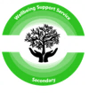
Secondary Wellbeing Support Service
21 Southbank Road
Kirkintilloch, G66 1NH
T: 0141 955 2342
www.secondarywellbeing.e-dunbarton.sch.uk
email: woffice@secondarywellbeing.e-dunbarton.sch.uk
Follow us on X: @wellbeing_ss

Service Handbook

Contents Page

Letter from Team Leader 2
Staffing 3
School Day 4
Leadership Team and Remits 5
Liaising with and involving Parents in their Child’s Education 6-7
Attendance at School 7-9
Comments, Compliments and Complaints Procedures 10-11
Ethos: Our Vision, Values and Aims 12-14
Children and Young People with Additional Support Needs 15-21

- Development of Spiritual, Moral, Cultural and Social Values
- Child Poverty
- The Promise
- UNCRC
- Pupil Conduct
- We say “No” to Bullying
- Pupil Voice
- Mobile Phone Use
- Dress Code

Curriculum and Transition: Learning in SWSS 22-26
Careers: Skills Development Scotland 27
Assessment and Reporting 28-29
Support for Pupils 30- 31
Support for Learning Services 33
Support for Learning: Service Provision 34-36

    - Psychological Services
    - Conversation Logs
    - Health and Wellbeing
    - Pastoral Support
    - TAC Meetings

Wellbeing, Protecting and Safeguarding Children and Young People 37-38
- Child Protection and Safeguarding
GIRFEC 38-39
School Improvement 40-43
Transferring Educational Data about Pupils 44-46
- Data Protection
- Accessing your Child’s Data
- Freedom of Information
- SCOTxED
SWSS Polices and Practical Information 47-50

- Information in Emergencies
- Health
- Medication
- Education Maintenance Allowance (EMA)
- Catering
- Free School Meals
- Transport
- Use of Photographs and Video Filming involving Pupils
- Appointment of Adults to Voluntary Child Care Positions

PLEASE NOTE: The use of the word “parent” throughout this document refers to parents, carers and guardians.


Letter from the Team Leader

Hello,

Welcome to the Secondary Wellbeing Support Service (SWSS) handbook.

SWSS is a non-denominational and a co-educational resource. Open since 2015, it incorporates the former Secondary Social Emotional and Behavioural Needs (SEBN) Service and Short Term Advice and Response Team (START). Our purpose is to re-engage young people with their education through providing flexible and adaptable levels of wellbeing support, offering advice to young people and their families as they work towards qualifications and young adulthood. The service supports secondary pupils across East Dunbartonshire.
Having moved into new facilities in May 2024, our base is situated in the heart of Kirkintilloch with links to other services such as Positive Achievements and the Outdoor Education Service. Our base has five teaching rooms which are fully equipped to provide high quality learning and teaching. SWSS offers full time and part time placements as well as an Outreach Service supporting pupils that have disengaged with learning and require wellbeing support in order to build confidence and positive relationships with school staff. Our curriculum is underpinned by the capacities outlined in Scotland’s Curriculum for Excellence, and staff are engaged in ongoing professional learning to ensure the best possible educational experience is available for our pupils. SWSS works with partners that provide both curricular and vocational options in addition to transitional and personal support.
I hope you find the contents useful and informative, but should you require further information do not hesitate to contact the service.

Regards, Mr P Quinn

Our Staff Team

Position | Name | Subject/ Role
Team Leader | Mr P Quinn | Senior Leadership
Acting Principal Teacher DYW Coordinator | Ms S Rae | Transitions  Social Subjects  Outreach
Teacher | Mr L Biennier | Administration and IT  Business Management  Personal Development  Outreach
Teacher | Miss R Ferguson | Psychology  Mental Health and Wellbeing  Personal Development
Teacher | Mrs J Reedie | Art and Design  Mental Health and Wellbeing  Photography  Personal Development
Teacher | Mr McBryan | English  Personal Development
Teacher | Miss K Pang | Mathematics  Personal Development
Pupil Support Assistant | Mrs S McCallum
Pupil Support Assistant | Miss K Trotter
Pupil Support Assistant | Mrs D McMunn
Clerical Assistant  Service Support  Facilities Assistants  Therapy Dog | Ms D McArthur  Ms L Fox/ Mx N Barrett  Ms L Campbell  Mr S Davis  Ms L MacMillan  Benni

Benni our Therapy Dog

Benni has been with us now since 2021. He was born in Barcelona.
Benni is a pedigree Australian Cobberdog. The Australian Cobberdog is a hypoallergenic breed and has the ideal temperament for therapy and assistance work as they are calm and very tolerant of humans and their behaviours. For more information on Cobberdogs please visit the following website:
https://www.cobberdogking.com/en/therapy-assistance-dog/australian-cobberdog-therapy-dog/
Our young people experience many barriers to learning ranging from mild to severe and enduring. Anxiety and stress are often identified as major contributing factors to these barriers. Research shows that interacting with a dog can moderate stress by reducing the heart rate, lowering blood pressure, and other observable supportive signs of anxiety. Benni has been a valuable addition to our community, much loved by young people and staff.

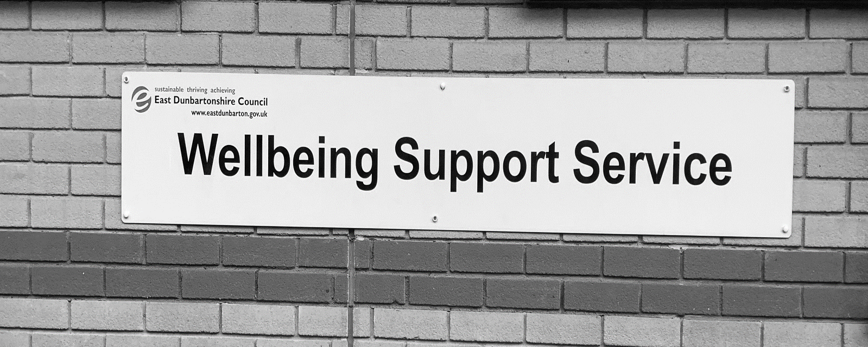

Our School Day

 | Get ready to Learn | Period 1 | Period 2 | Break Time | Period 3 | Period 4 | Lunch Time | Period 5 | Period 6 | Relax
 | 9.00 - 9.15 | 9.15- 10.05 | 10.05- 10.55 | 10.55 11.10 | 11.10- 12.00 | 12.00- 12.50 | 12.50- 13.40 | 13.40- 14.30 | 14.30- 15.20 | 15.20- 15.30
Monday
Tuesday
Wednesday
Thursday
Friday

Leadership Team and Remits

P Quinn Team Leader | - Pupil Welfare and Child Protection  - Appointment and Deployment of all SWSS Staffing  - Staff Welfare  - Financial Management  - School Fund (in conjunction with S Rae)  - Liaising with Parents  - School Calendar and WTA  - Curricular Pathways, Curricula, Assessment and Reporting  - School Handbook  - School Improvement Plan  - Trips and Excursions  - Absence Cover  - Transport  - Standards and Quality Reports  - Self-Evaluation and Quality Assurance  - Timetable (in conjunction with J May)  - Options Process (in conjunction with S Rae)  - Health and Safety  - SQA Coordinator (in conjunction with S Rae)  - Fire Safety Procedures and Risk Assessment  - Professional Learning Coordinator  - Professional Review and Development and Professional Update  - Partnership Management (in conjunction with S Rae)

S Rae  Acting Principal Teacher DYW Coordinator | - Responsibility for Developing the Young Workforce  - SQA Coordinator (in conjunction with P Quinn)  - Transitions  - Senior Phase Curricular Pathways  - Partnership Management  - Coordination of all vocational programmes and links with Post 16 institutions  - Senior Phase Transitions  - Work Experience  - Learning for Sustainability Outdoor Programme

Assistance to Leadership  J Reedie | - ICT Coordinator  - Monitor and Tracking (In conjunction with P Quinn)  - Timetable (In conjunction with P Quinn)

LIAISING WITH AND INVOLVING PARENTS IN THEIR

CHILD’S EDUCATION

Parents Welcome

All East Dunbartonshire Council schools welcome parental involvement as research has shown that when parents are involved children do better in school.

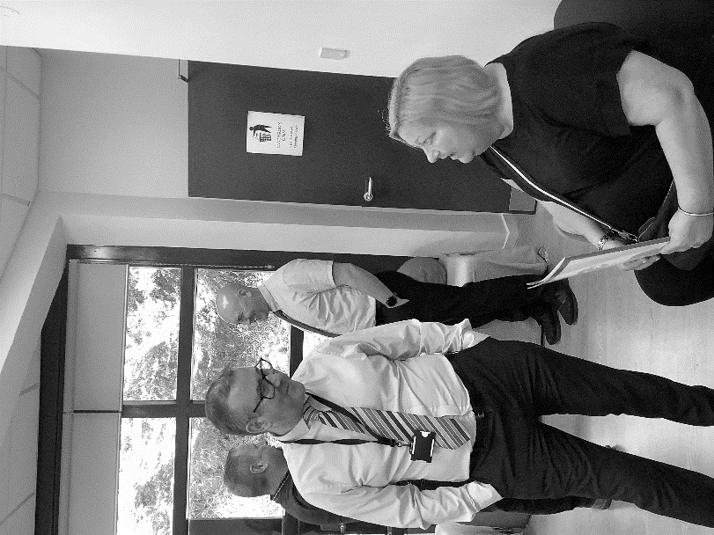
It is the policy of the Team Leader to encourage the fullest contact possible between the service and parents. A strong partnership between parents and teachers can only be beneficial to a child’s progress and sense of wellbeing as he or she progresses through the service. A first point of contact for parents will be contacting our Clerical Assistants who will disseminate any information to Mr Quinn or Mr Marshall. The service will contact parents when possible. Our teachers have specific responsibilities for the general welfare of the children within our service. Our daily contact between teaching staff and our young people provides an opportunity to communicate regularly and build strong trusting relationships that will support our young people and their families. A termly newsletter and updates on different topics throughout the year are sent home using email, and it is intended that these should provide parents with a regular overview of the events in the school.
Information on service events and news can be viewed on our website: www.secondarywellbeing.e- dunbarton.sch.uk.
Pupil reports are sent home on a regular basis and parental comments on progress are welcome. In addition, parents are invited to a Parents’ Evening where they will have an opportunity to discuss their child’s progress with his/her teachers. Parents are welcome to come to the service at any time although it is preferred if an appointment is made in advance, either by telephone, email or letter. The Team Leader or Principal Teacher will normally be available to discuss matters of a confidential nature.

Unlike mainstream schools, SWSS does not carry a pupil roll. All young people who attend here remain on the roll of their mainstream school. We firmly believe the options and opportunities at mainstream school far outshine what this service can offer. Our young people have the benefit of using the resources and facilities of both campuses to support them and meet their needs. As a result, our varying pupil numbers does not constitute to having a Parent Council but we support our parents with several events throughout our school year. Our Parent Calendar provides an opportunity for our teaching staff and families to come together to discuss topical issues that is impacting education, health or our local community in addition to providing peer support from family members to each other. Most of our families have experienced Emotional School Based Avoidance (EBSA) or other barriers to school attendance and can provide first class advice and support to other families. The small size of our community is a strength of our service.
The main aims of the Parent Calendar are:

• To support the school in its work with pupils
• To represent the views of parents
• To promote contact between the school, parents, pupils and the community
• To provide support for parents and families with attendance barriers

Our Parent Calendar 2026-27

Event | Date | Time
Introduction Evening | Thursday 3rd September 2026 | 5-7pm
Parents Consultation Evening 1 | Thursday 12th November 2026 | 5-7pm
Parent and Carer’s Consultation Evening | Thursday 26th February 2027 | 5-7pm
Parents Showcase Evening | Thursday 30th April 2026 | 5-7pm
Celebration Evening | Thursday 17th June 2027 | 5-7pm

Pupil Progress Reporting to Families 2026-2

Term | Report issued
1 (Aug- Oct) | Monday 26th October 2026
2 (Oct- Dec) | Monday 11th January2027
3 (Jan- Mar) | Tuesday 30th March 2027
4 (Apr- Jun) | Monday 14th June 2027

For more information on parental involvement or to find out about parents as partners in their children’s learning, please contact the school or visit the Parentzone website at https://education.gov.scot/parentzone
The Scottish Parent Teacher Council (now known as Connect) is the national organisation for PTAs in Scotland and runs an independent helpline service for all parents. They can be contacted by phone on 0131 474 6199, or email on info@connect.scot or write to Connect, Mansfield Traquair Centre, 15 Mansfield Place, Edinburgh EH3 6BB.

Attendance at School
Scottish local authorities have the responsibility to review and revise their procedures for managing situations where children fail to attend their school/early years centre and no explanation for absence is received from their parents. East Dunbartonshire Council recognises that under such circumstances, children may be vulnerable to harm and that timely steps must be taken to ensure that an absent child is safe and well.
Children missing from education are children and young people of compulsory school age who are not on a school roll and are not being educated otherwise (at home, privately or in an alternative provision). They have usually not attended school for a period of time.
Attendance must be recorded twice a day, morning, and afternoon. Each child’s absence from school to be recorded in the school register as authorised i.e. approved by the authority, or unauthorised i.e. unexplained by the parent (truancy) or temporarily excluded from school.
The Scottish Government emphasises the need for schools to support attendance for all and create appropriate support for those who find attending school a challenge. Attendance is defined as the “participation in a programme of educational activities arranged and agreed by the school” (Included, Engaged and Involved: Part 1). Engaging in school and in learning is crucial to ensure that children and young people meet their full potential.

Attendance Percentage | Days Absent |  | Further Information
95% | 9 days | Attendance at or above this level gives a learner the best chance of success.
90% | 19 days | Attendance at this level leads to less chance of success.  Data shows that learners missing this much school could drop a whole grade in secondary.
80-85% | 27-36 days | Attendance at this level has serious implications for learning and progress.

There are a key rights, duties and legal obligations in relation to attendance as outlined in ‘Included, Engaged and Involved (Part 1)’.

These are set out below:
- All children and young people have a right to education; and education authorities have a duty to provide education.
- All children and young people have the right to get the support they need to benefit fully from their education and fulfil their potential.
- All children and young people need to be included, engaged and involved in their learning. Children and young people should be given opportunities to fully engage and participate in the life of their school, in order to encourage good attendance.
- Schools should actively engage with parents to try to ensure that any barriers to good attendance are removed.
- Schools and partners should work collaboratively to promote and support good attendance.
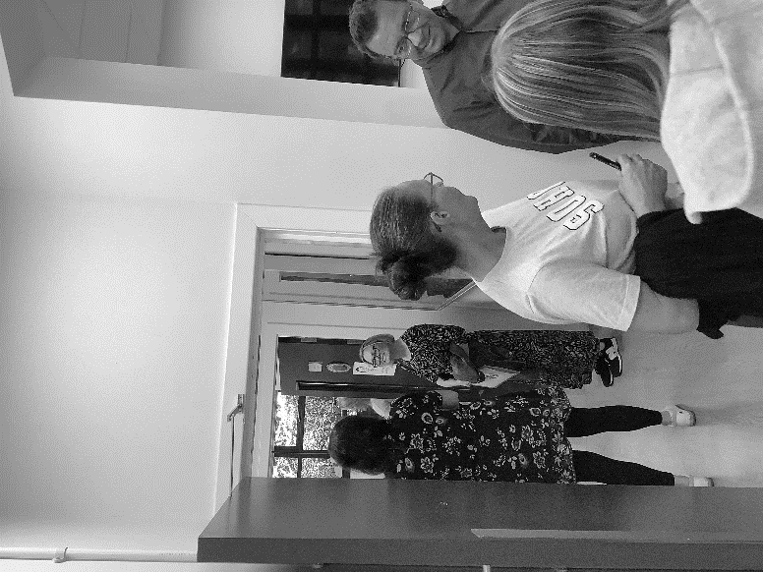
- The foundation for schools, learning establishments and education authorities is a focus on positive relationships and an inclusive ethos and culture that promotes good attendance. Attendance should not be considered in isolation.
All children and young people have a right to education; and education authorities have a duty to provide education. All children and young people have the right to get the support they need to benefit fully from their education and fulfil their potential. All children and young people need to be included, engaged and involved in their learning. Children and young people should be given opportunities to fully engage and participate in the life of their school in order to encourage good attendance. Schools should actively engage with parents to try to ensure that any barriers to good attendance are removed. Schools and partners should work collaboratively to promote and support good attendance. The foundation for schools, learning establishments and education authorities is a focus on positive relationships and an inclusive ethos and culture that promotes good attendance. Attendance should not be considered in isolation.

Un-notified Absence
Parents have the primary duty of care for their children. During school/centre hours (and during registered school/centre activities), schools/centres must take all reasonable steps to keep children safe from harm. The effective implementation of the procedures will require parents/carers and schools/centres to exercise their respective duty of care and to work in partnership to help to ensure that children are kept safe from harm.
In order to respond appropriately to an un-notified absence, it is important that parents exercise their duty of care, by notifying the school/centre when their child will be absent and the reasons for this. Each session parents will be required to notify their child’s school/centre of all absences.

Missing in Education
Children missing from education are children and young people of compulsory school age who are not on a school roll and are not being educated otherwise (at home, privately or in an alternative provision). They have usually not attended school for a period of time.
Additional guidance is in place to ensure inter-agency collaboration, involving education services, social work, health services and the police to ensure the safety and educational development of the child. The process aligns with The Children Missing from Education (Scotland) Service in Scotland.
(Attendance, exclusion and missing in education-Schools-gov.scot)
Schools should ensure their Child Protection Co- ordinator is notified and seek central support from the ASN and Children’s Services team if they have any concerns.

Family Holidays
Every effort should be made to avoid family holidays during term time as this seriously disrupts a child’s education and greatly reduces learning time. It should be noted that it not only has an adverse effect on a child while he/she is absent from school, but also leads to extended disruption to a child’s education for a period of time when he/she returns to school after the family holiday. Family holidays will only be regarded as authorised absence where prior agreement from the school has been obtained and where it is judged the holiday is important to the wellbeing and cohesion of the family, following serious or terminal illness, bereavement, or other traumatic events.

Parents may request that their children be permitted to be absent from school to make an extended visit to relatives. This leave will be regarded the same as a family holiday but will be recorded separately from school holidays for attendance purposes. Requests should be made in writing detailing the destination and the duration.
Clearly with no explanation from the parents, the absence is unauthorised.

Information regarding exceptional closures
We make every effort to maintain a full educational service, but on some occasions circumstances arise which lead to disruption. Schools may be affected by, for example, severe weather, temporary interruption of transport, power failures or difficulties of fuel supply. In such cases we shall do all we can to let you know about the details of closure or re-opening. We shall keep you updated using the usual digital methods of communication used by the school i.e. email, Groupcall or social media. There will also be updates on the website www.eastdunbarton.gov.uk

(a) Parental Communication with School in Case of Emergency

It is important that parents keep contact with the school to a minimum in the case of an emergency. When you telephone the school you will be asked for a contact number and your message will be repeated back. Please ensure the pupil’s name, class and/or teacher’s name is given.

Please ensure that your child knows their home/pick up plan each day. If there are any changes to childcare arrangements, please inform the school before 2.30pm. This should only happen in exceptional circumstances.

Comments, Compliments and Complaints Procedure

We are keen that you should be completely satisfied about your child's education and we encourage feedback on our services from parents and pupils. We are, therefore, interested in feedback of all kinds, whether it be comments, compliments, or complaints.
If you want to register a comment of any type about the school you can do this by writing, e-mailing, telephoning or making an appointment to see someone. All feedback is welcome and keeps us in touch.
If, in particular, you have a complaint about the school, please let us know. It is better that these things are shared openly and resolved fairly, rather than being allowed to damage the relationship between the family and the school.
There will be no negative consequences arising from making a complaint and we will deal with the issue as confidentially as possible.

In relation to making a complaint:
- Stage 1 – Frontline resolution, we will always try to resolve the complaint quickly and to the customer’s satisfaction wherever we can. This resolution will be provided within five working days, unless there are exceptional circumstances.
- Stage 2 – Investigation, if you are dissatisfied with the decision at stage 1, the complaint will be investigated, acknowledge in three working days and decision provided as soon as possible but within twenty working days.

- If you are still unhappy after the further investigation and reply you can take the matter up with the Scottish Public Services Ombudsman (SPSO), our reply will include the contact details.
- You should also note that you have the right to raise unresolved concerns with your local councillors, MSP or MP.

The Education Service is keen to ensure that it involves all parents appropriately and sensitively in their child’s education. Under Education Law, “parents” include:

- Non-resident parents who are liable to maintain or have parental responsibilities in respect of a child;
- Carers who can be parents;
- Foster carers, relatives and friends who are caring for children under supervision arrangements;
- Close relatives, such as siblings or grandparents caring for children who are not “looked after and accommodated” by the local authority or are under home supervision (looked after) arrangements.

Child Friendly Complaints.
Child-friendly complaints are processes designed to allow children and young people to raise concerns or complaints in a way that respects their rights, ensures accessibility, and provides appropriate support.
Child-friendly complaints processes are structured to empower children and young people to express concerns about services, treatment, or decisions affecting them. These processes are guided by the United Nations Convention on the Rights of the Child (UNCRC), ensuring that children’s rights are central to complaint handling and that their views are taken seriously

The benefits of ensuring our Child Friendly Complaints processes are fully embedded to ensure that:

- They can voice their concerns safely and confidently
- Receive responses that respect their rights and needs
- Contribute to improvements to the Council through meaningful feedback

In embedding these principles East Dunbartonshire are complying with our legal obligations under the UNCRC, and fostering a culture of respect, inclusion and accountability for children and young people.

Further information can be found using the following link - Child Friendly Complaints | SPSO

We will take account of our parent/carer needs and will respond with patience and understanding when parent/carers have specific requirements of us. We recognise that some of our parent/carers will encounter the Council at difficult times in their lives and/or when experiencing challenging circumstances, and that this may cause them to act in ways that are out of character, however, the Council has clear expectations around how we aspire to deliver excellence in parent/carer services. We would always suggest that contacting your child’s school in the first instance to try and respond to any complaints quickly.
For further information around Council policy please see the link below:
Unacceptable Behaviour Policy 2024 – 2028 - East Dunbartonshire Council
Section 2 Parental Involvement and Engagement and family learning

- The opportunities provided for a parent to become involved in the school – supporting learning at home, improving home-school partnerships and parental representation. Signpost to the Parental Engagement Strategy.

- How the school communicates with parents – parents’ evenings, school assemblies and events, classroom visits, e-mail, website, text messaging, radio, phone calls, letters, newsletters etc. - This should include updated arrangement for this session.

- How the school involves parents in the pupils’ education, how information, support and advice is given to parents to help parents support the pupil’s learning and at key stages, particularly when choices are being made. How schools gather parent opinion and encourage parents to share their views. - As above, this should include updated arrangement for this session.

- Include information which highlights the school’s approaches to engaging and involving parents – direct and easy access, responsive, tools for continuous engagement e.g. homework diaries, open access times – ‘drop ins’. - Please advise about current arrangements

- Information about the role of the parent council in representing their views on education matters and how they can contact them.

Scottish Schools (Parental Involvement) Act 2006
Family engagement and support for parents - East Dunbartonshire Council

School Ethos.

Our Vision
We aim to provide high quality, personalised learning in a safe and nurturing environment. Our service gives young people the space and support they need to continue with their studies throughout the time they are with us.

Our Values

- Clarity: We are coherent and understanding.
- Integrity: We are honest and have strong moral principles.
- Openness: Our school is a place that is broad- minded, unbiased and all are accepted.
- Perseverance: We want to succeed and get better at using important skills that we often find difficult.
- Respect: We are all equal and show consideration to others and oneself.

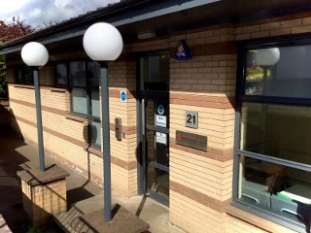
Our Aims

- To provide opportunities for personnel achievement and attainment
- To develop skills for learning, life and work
- To promote emotional health and wellbeing
- To promote physical wellbeing
- To ensure young people are safe, nurtured, respected and responsible

Ethos
It is fundamental to our work at SWSS to ensure that our pupils leave school as self-assured, confident and socially skilled young people aware of the individual strengths which they each have. To this end all members of the teaching and non-teaching staff are aware of the importance of their pastoral role and of establishing a prevailing atmosphere in the school which is friendly, supportive and pupil-centred. A great deal of time is invested, out with normal class times, in helping pupils individually, in participating in extra-curricular activities, trips and visits because we believe that the relationships which develop through such involvement, genuinely support and improve the learning process.
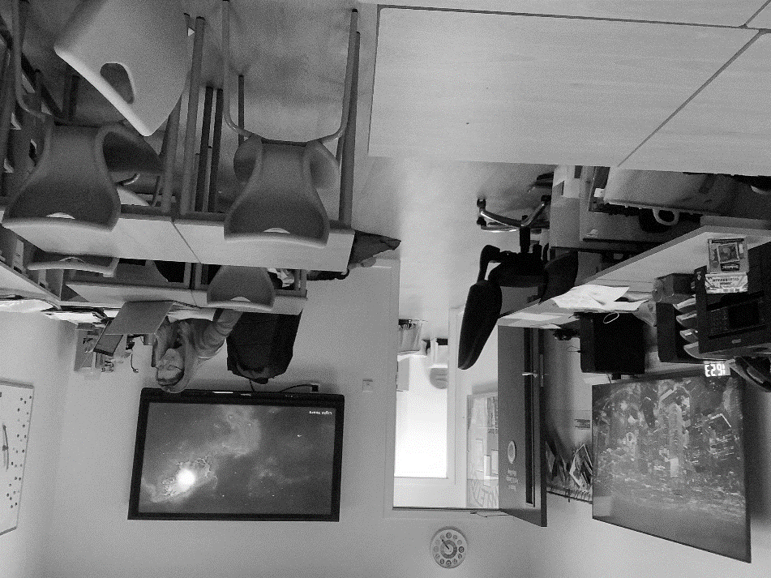
The curriculum is delivered by teachers who ensure that each pupil is given work appropriate to their age, stage and learning needs, and that successful learning is reinforced by regular monitoring and assessment. All pupils are supported in this by service staff as they progress through with us, but some pupils may require additional or alternative forms of support. This support is offered by a member (or members) of the SWSS Team as well as external partners associated with the service or East Dunbartonshire Council. Some pupils with additional support needs may require a Coordinated Support Plan: this will be considered in liaison with officers of East Dunbartonshire Council. Support for pupils is coordinated by Mr Quinn, Team Leader, who liaises regularly with all those concerned.

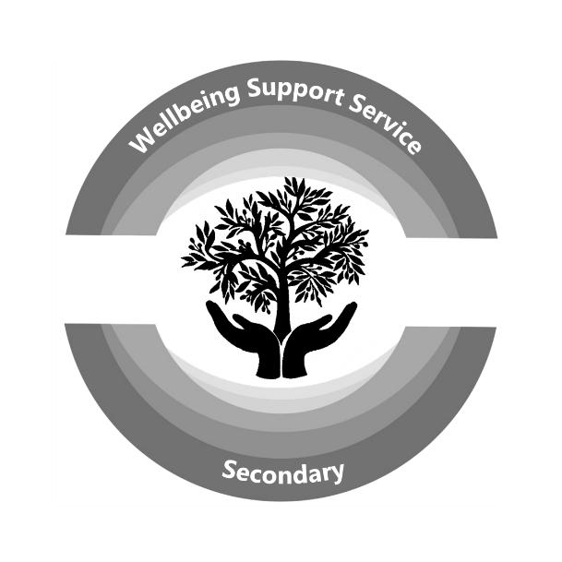

EAST DUNBARTONSHIRE COUNCIL’S Vision, Values and Aims

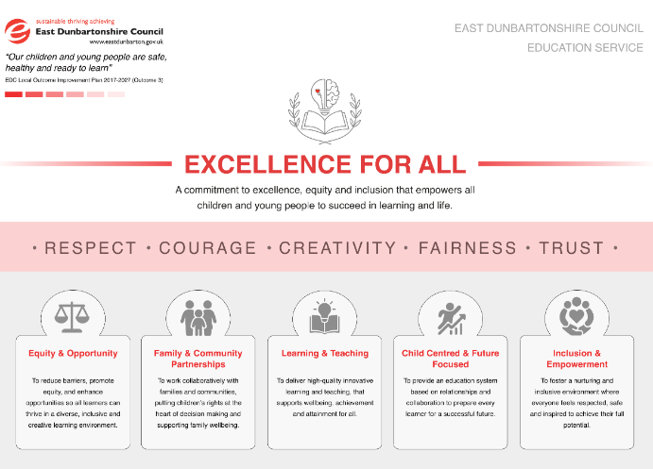
The Vision for the Education Service is ‘Excellence for All - A commitment to excellence, equity and inclusion that empowers all children and young people to succeed in learning and life’.
This Vision is combined with the carefully chosen values of respect, courage, creativity, fairness and trust to encapsulate the skills, actions and values expected for all our staff, children and young people.
Underpinning our commitment to continuous improvement for all, five aims were identified as overarching priorities. These aims will be measured against the Education Service improvement priorities to ensure a key focus on improving outcomes for all.
These are as follows:
Equity & Opportunity
To reduce barriers, promote equity, and enhance opportunities so all learners can thrive in a diverse, inclusive and creative learning environment.
Family & Community Partnerships
To work collaboratively with families and communities, putting children’s rights at the heart of decision making and supporting family wellbeing.
Learning and Teaching
To deliver high-quality innovative learning and teaching, that supports wellbeing, achievement and attainment for all.
Child Centred and Future Focussed
To provide an education system based on relationships and collaboration to prepare every learner for a successful future.
Inclusion and Empowerment
To foster a nurturing and inclusive environment where everyone feels respected, safe and inspired to achieve their full potential.

The visual representation of the Vision, Values and Aims was carefully considered. The symbolisation of mind, knowledge, growth, and success is at the heart of the concept. The graphic combines the brain representing critical thinking; the light bulb as a symbol of ideas and innovation; the heart as a symbol of care, compassion and emotional intelligence; the open book as the traditional symbol of knowledge and learning and finally the laurel symbolising growth, harmony and aspiration.

Education Scotland’s Thematic Review of the Education Service in September 2024 highlighted the following strength.
“The culture of high levels of trust, high aspirations and high expectations permeates all levels of the system. The relationship-based approach leads to highly effective collaboration at all levels with a strong focus on improving experiences for children and young people.”

CHILDREN AND YOUNG PEOPLE WITH ADDITIONAL SUPPORT NEEDS

EQUAL OPPORTUNITIES FOR ALL

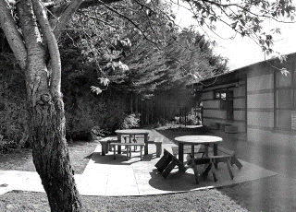
In East Dunbartonshire, all children and young people are entitled to participate fully in a learning community which promotes equality of opportunity and seeks to protect against all forms of discrimination.

The school believes that pupils and staff have the right to learn in a caring and safe environment. Staff will not tolerate any behaviour or attitudes which lead to staff and pupils being humiliated or harmed because of their age, disability, gender reassignment, marriage and civil partnership, [pregnancy and maternity, race, religion or belief, sex and sexual orientation.

The General Equality Duty was created by the Equality Act (2010) and replaces the race, disability, and gender equality duties. The duty came into force in April 2011 and covers age, disability, gender reassignment, marriage and civil partnership, pregnancy and maternity, race, religion, or belief, sex, and sexual orientation.

The school is committed to the requirements of the Equality Act (2010) and as such we will have due regard to the need to:
- Eliminate discrimination, harassment and victimisation.
- Advance equality of opportunity between children and young people who share a characteristic and those who do not;
- Foster good relations between different groups.
The school will take cognisance of the Equality and Human Rights Commission’s ‘Technical guidance for schools in Scotland’ in the development of its policy and practice.
Technical guidance for schools in Scotland | EHRC (equalityhumanrights.com)

Development of Pupils’ Spiritual, Moral, Cultural and Social Values
The service is committed to supporting the development of its pupils as whole people and as a result, wishes to encourage their development in spiritual, moral, social and cultural terms.
These key human aspects of learning are supported through the following arrangements by:
- Creating a school ethos which, in every way possible, gives value to these aspects of development, especially by providing an overall atmosphere that is both caring and challenging and which provides opportunities for the development of personal responsibility.
- Promoting social and moral learning through the way in which disciplinary issues are handled.
- Ensuring that staff and adults within the school provide positive models for pupils.
- Arranging regular gatherings of the school as a community and using such occasions to encourage and reinforce the values on which the school is based.
- Enriching the curriculum in all appropriate areas with an emphasis on spiritual, moral, social and cultural development.
- Providing opportunities within the curriculum to advance personal and social development.
- Providing a programme of religious education in which consideration will be given to responses to basic questions relating to the meaning, value and purpose of human life.
- Providing a programme of moral education.
- Taking every appropriate opportunity to acknowledge, value and appreciate the various cultures and heritage of the pupils and to encourage them to appreciate and value the cultures and heritage of others

Service Policy
All our policies – whole-school and departmental – will be judged in relation to this overall aim.

A successful school is one where teachers and pupils strive towards common goals.

Pupils respond to and respect teachers who are thoroughly prepared in their work and who set realistic aims for each individual. The hallmark of our professionalism is our ability to strike a sensible balance between the particular needs of the individual and the needs of the group. Success for some pupils will be academic work of the highest standard while for others sustained attendance at school may in itself represent a very worthwhile achievement. A number of our pupils come from less privileged home backgrounds; for some the school represents the most stable influence in their lives; an education service of genuine quality is sensitive to the needs of all pupils and aims not only for the highest academic success but also to raise the self-esteem of each individual.

Child Poverty
The impact of poverty can have a significant effect on children’s achievement and attainment.
The Cost of the School Day is a national policy to help raise awareness of the financial barriers families with low income can face and how that can negatively impact on children and young people, especially with regards to their mental health and wellbeing.
In school, supports are in place to ensure barriers to accessing learning are removed and equitable access is in place for all, regardless of their family or carer’s financial background.
If you have specific concerns, please contact the service or mainstream school to discuss as there are ways in which support can be provided.
The Promise
East Dunbartonshire Council is committed to keeping The Promise and supporting our care experienced learners. The findings of The Independent Care Review (The Promise 2020) and documents produced by The Promise Scotland, including Plan 21-24, Change Programme 1 and individual service briefings, have helped to inform the plan and can be viewed here https://thepromise.scot It is crucial that, in order for The Promise to be kept, the calls to action as outlined within The Promise underpin all existing and future plans of support for children, young people and families within East Dunbartonshire.

UNCRC
East Dunbartonshire Council is committed to developing rights-based approaches in all education establishments. A rights-based approach ensures the articles of the convention underpin the ethos of the organisation and all policy and practice is developed under consideration of the United Nations Convention on the Rights of the Child (UNCRC).
Implementation of the UNCRC July 2024, ensures children and young people’s rights are integral to every aspect of decision making, policy and practice in our schools and early years centres. Our pupil forum My Voice My Choice has members from all schools ranging from P6 to S4 year groups. Rights Respecting School Awards are undertaken by all our schools, which encompasses the entire school community.
UNCRC in SWSS
Our Pupil Forum/ Council, Your Rights, Your Voice, has members from all our year groups and meets monthly to discuss current service issues and service development. In addition, we have our monthly service coffee morning where our community come together to relax and have some fun. We are currently being assessed for our Silver Rights Respecting School Award after achieving our Bronze Award.

We aim to:
  - Ensure our service have clear guidance on children’s rights; what they are and how they will be embedded in the life of the service
  - Work closely with partners to ensure we develop a positive and inclusive ethos and culture
  - Ensure provision of information, training, advice and support to those working with young people as well as their parents or carers
  - Provide leadership and ensure accountability through systematic monitoring and review of data

Promoting Positive Relationships, Behaviour and Learning in Education

In East Dunbartonshire’s schools’ the development of relationships and skilled support for children and young people to manage their behaviour is essential. The whole school community endeavours to create a caring, nurturing, optimum learning environment, which promotes creativity, whereby everyone feels empowered, supported, and loved.
This is a clear framework which can be used and adapted to support Relationships Policies in all schools and educational establishments. East Dunbartonshire Council (EDC) is committed to providing a culture in the school community where all stakeholders including children, staff and parents feel included, respected, safe and secure and where their achievements and contributions are valued and celebrated. Positive relationships should be encouraged and present throughout the whole school community where children and young people are involved meaningfully in decisions which affect them.
We aim to:

Pupil Conduct
A partnership between the school and parents is required in order to ensure the best possible standards of pupil conduct. Pupils are expected to set themselves high standards in behaviour and adopt our agreed dress code. School rules have been devised to encourage the maximum amount of self-discipline. The rules themselves are relatively simple and few in number to allow for the smooth running of the school. The general aim is to produce an atmosphere of friendly co-operation, encouraging respect and consideration for other persons and for property.
The relationship between pupils and teacher is mutual consideration on both sides. To create this environment, SWSS have an agreed number of rules that we ask our community to follow. We wish to create a happy and pleasant environment for all our community members to enjoy. When we have people who respect and feel respected they will be committed to embracing our community and make it thrive. It is our aim in SWSS to encourage responsible attitudes and self- discipline of all our pupils and to have a sense of pride and wellbeing their school. Through our Pupil Council we actively encourage our pupils to be part of managing their school through voicing their opinions and suggestions.

At the Wellbeing Support Service, we expect:

- Arrive on time, prepared to learn
- Engagement with classes & activities
- Willingness to follow instructions
- To be safe
- Respect for others
- Respect for property
- Equal Opportunities
- Correct use of Phone – see separate policy on website
- Dress Code to be met

At the Wellbeing Support Service, we will not tolerate:

- Offensive language
- Drugs or Alcohol abuse
- Vandalism or litter
- Aggression, fighting or possession of an offensive weapon
- Bullying or intimidation of others
- Discrimination

We say “No” to Bullying
SWSS is committed to ensuring that all our pupils are happy and safe within the service. We aim to create a climate in which everyone is respected, feels secure and is able to seek advice. The responsibility for achieving this aim lies with every member of the school community, i.e. all staff, pupils and parents. We have to create a partnership with everyone working together to achieve a safe school.
It is crucial to take into account the impact that bullying behaviour has on a child or young person. The impact an incident has on a child or young person is more important than whether it is classified as bullying. Actions can affect people in different ways and this should be taken into consideration. The person who has experienced harm may have experienced just one event. The impact determines the definition of bullying. One incident is sufficient to alert adults to take supportive action.
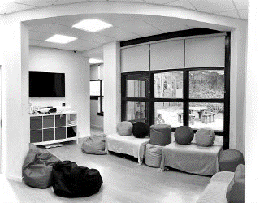
Not every unkind behaviour constitutes bullying. Children and young people are still learning how to get along with others. They will tease each other, fall in and out with each other, have arguments, stop talking to each other and disagree about what they like and don’t like. These are examples of ordinary conflict, perhaps thoughtlessness and possibly insensitive behaviour and should be viewed as a normal part of growing up. However, if left unchecked, these behaviours can lead to bullying, making those being bullied feeling afraid, uncomfortable or unsafe in their environment. They should be viewed as an opportunity to help children and young people learn about resolving conflict and getting along with others. Parents, teachers and other adults need to model kindness, conflict resolution, inclusion and responsibility. Consideration should be given to the sanctions and support given to the young person displaying bullying behaviour ensure that interventions are intended to improve behaviour.

Such approaches might include:

- positive behaviour strategies with an appropriate member of staff, as agreed;
- restorative approaches;
- solution orientated approaches;
- involvement of educational psychologists and campus police.
A copy of our anti- bullying policy is available on our website

PUPIL VOICE
Pupil Voice describes ways in which the pupils of SWSS can give opinions, take action and influence decisions that affect our School Community. Pupil Voice is very important in helping the Service develop in ways which help it best serve our young people. Examples of how SWSS develops Pupil Voice can be seen below.

- PUPIL COUNCIL Each year the pupil body nominate 2 representatives who collect information about pupil issues and then meet to discuss them with staff. The Pupil council have affected several changes in the running of the School such as service coffee morning and school meals. Furthermore, the student council are involved in:
- SCHOOL IMPROVEMENT PLAN/SELF EVALUATION
- PROMOTING POSITIVE BEHAVIOUR POLICY
- SCHOOL DRESS CODE
- RIGHTS RESPECTING SCHOOLS COMMITTEE
The Rights Respecting Schools Committee (RRSC) is the steering group for the School’s work on the Rights Respecting School’s Award from UNICEF.
To date, our Bronze Award is pending and we are working with all members of the Service Community to further embed knowledge of the UN Convention of the Rights of the Child (UNCRC) and so progress to Silver Award status.
- WIDER STUDENT BODY VOICE
In addition to this targeted work the wider student body is also provided with opportunities to have their voice heard in the following ways.
- PARTICIPATION IN STAFF RECRUITMENT PROCESS
- WHOLE SCHOOL SURVEY ON CURRENT PRACTICE

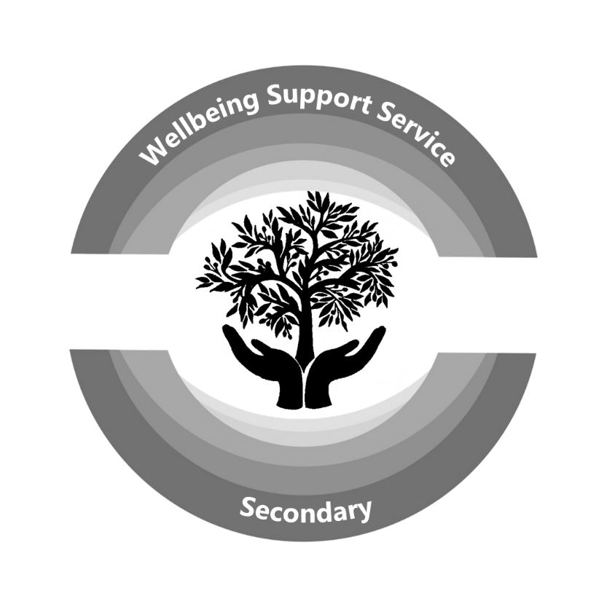
THE USE OF MOBILE DEVICES IN SCHOOLS
This policy sets out the East Dunbartonshire Council framework on the use of mobile devices (e.g. phones, tablets and smartwatches) in schools. It aims to support learning and teaching, safeguard young people, promote consistency, and ensure equity of access across schools. The policy aligns with Scottish Government guidance (2024) and reflects the outcomes of extensive stakeholder engagement. Mobile device use should be guided by clear educational purposes that reflect teacher professionalism and context specific judgement.

Operational Guidance

- Mobile devices are not permitted in lessons unless expressly authorised by the class teacher for a specific planned educational task. If approved use has not been given, mobile devices should be switched off and remain out of sight.
- Use of mobile devices during interval and lunch times may be permitted and should be considered in consultation with pupils and staff. Where allowed, clear expectations and boundaries must be established to promote wellbeing, inclusion, and responsible use such as listening to music with earphones.
- Exceptions may be granted for medical, communication, or additional support needs, with parental agreement and Head Teacher approval. If use of mobile devices is permitted clear expectations and boundaries must be established to promote wellbeing, inclusion, and responsible use.
- The use of mobile devices is strictly prohibited during assessments or examinations.

Safeguarding and Prohibited Uses

All schools must ensure rigorous measures are in place to ensure that mobile technologies are not misused. Staff are required to be vigilant and report breaches to their line manager. The following are strictly prohibited:
- Recording or photographing staff, pupils, or premises without explicit consent.
- Audio recording of lessons or individuals.
- Sharing school-related content on social media without approval.
- Engaging in any form of online cyberbullying.
- Accessing, viewing or sharing content which is of a violent or adult nature.

Policy Exceptions

Exceptions may be granted where justified and supported by appropriate documentation. This may include:
- A medical requirement (e.g. continuous glucose monitoring).
- A communication need (e.g. augmentative technology).
- A documented additional support need (e.g. ASN Action Plan).
Young carers who require ongoing contact with family members.

Dress Code
The young people who attend SWSS have the option not to wear their mainstream school uniform. We aim to prepare our pupils for all aspects of life beyond school. Whilst we value individuality and appreciate the importance of feeling comfortable, pupils need to recognise that appropriate dress, along with basic etiquette, are common requirements in the work place and professional settings.
Therefore, the following regulations apply both within our school building and during school excursions:

- No see-through clothing or strapless, low-cut tops
- No visible underwear or mid-drifts
- Shorts and/or skirts to be a minimum of ‘fingertip length’
- No clothing with offensive / inappropriate slogans or images – including football colours
- We prefer no hoods up or hats on during class time but we understand their protective use
- No high heels
- No extended jewellery
Failure to comply with the dress code will be addressed using the process outlines in our Relationship & Behaviour policy.
Young people who have a split placement with SWSS and their school will be given the option of wearing their school uniform or prior to visiting their school or returning from the school will be given facilities to dress into appropriate clothing. SWSS will respect our partners in mainstream school’s uniform policy.

SERVICE CAMPUS NO SMOKING POLICY
With the introduction of the Smoking, Health and Social Care (Scotland) Act 2005 and the Prohibition of Smoking in Certain Premises (Scotland) Regulations 2006, East Dunbartonshire Council now operates a no smoking policy across all authority’s school campuses. Any person accessing the school must refrain from smoking in any of the service campus areas.

Curriculum and Transitions
The values, purposes and principles of the 3-18 curriculum in Scotland are set out in A Curriculum for Excellence. The curriculum aims to support children and young people to maximise their potential across four capacities to become successful learners, confident individuals, responsible citizens and effective contributors.
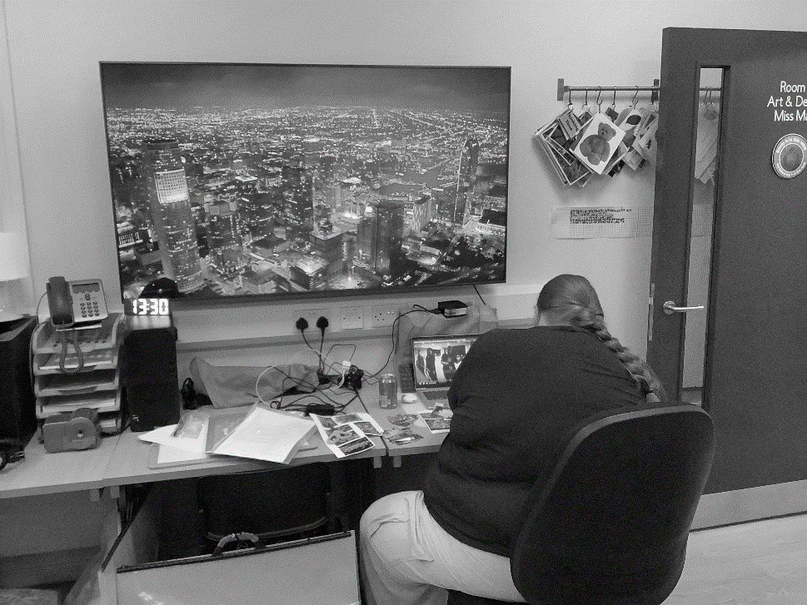
Curriculum for Excellence develops skills for learning, life and work, bringing real life into the classroom, making learning relevant and helping young people apply lessons to their life beyond the classroom. It links knowledge in one subject area to another, helping children to make connections in their learning. It develops skills which can enable children to think for themselves, make sound judgements, challenge, enquire and find solutions.
Curriculum for Excellence balances the importance of knowledge and skills. Every child is entitled to a broad and deep general education, whatever their level and ability. All teachers are responsible for the development of literacy, numeracy and health and wellbeing.
In line with Education Scotland, our school is committed to providing high-quality learning experiences through Scotland’s Curriculum Improvement Cycle. This national approach supports continuous improvement by ensuring that the curriculum remains relevant, inclusive and responsive to the needs of children and young people in a changing world. It enables schools to review evidence, reflect on practice, implement improvements and evaluate their impact, ensuring that learning continues to meet the aspirations of Curriculum for Excellence.
Through this process, we ensure our curriculum continues to develop the four capacities of Curriculum for Excellence, promotes equity and inclusion, reflects the principles of Getting it Right for Every Child (GIRFEC) and the United Nations Convention on the Rights of the Child (UNCRC), and supports every learner to achieve their full potential. Curriculum improvement is closely aligned with our School Improvement Plan and our self-evaluation using How Good Is Our School? (4th Edition), ensuring that our learners are equipped with the knowledge, skills, attributes and values they need for learning, life and work.
Curriculum Areas
- Expressive Arts – Art & Design, Drama, Dance and Music
- Health and Wellbeing
- Literacy & English
- Numeracy & Mathematics
- Religious and Moral Education (RME)
- Sciences
- Social Studies
- Technologies

Learning in SWSS

Many of the young people who attend our service have experienced a truncated learning journey for various reasons. Our policy in SWSS is to build on the foundations that have been fixed on to the learning journey of the young person and develop their skills for learning, life and work through high quality learning and teaching in a positive learning environment.
When a young person attends SWSS we will liaise closely with their mainstream school and any professional who they work with. Using the information that we receive, we will create a transition plan to allow they young person to re- engage with their educational journey. The transition will be co- ordinated by our managerial staff and can extend to 10 weeks. Importantly, this planning is done with a holistic approach to ensure we meet the needs of the young person. In our experience, slow steps at the pace of the young person is the approach that will be most successful. We have three transition routes that incorporate a preference of morning, mid-day and afternoons by the young person. Over a number of weeks, we will slowly work towards a full timetable and full placement. At times some of our young people will remain on a flexible timetable or a split timetable which incorporates time at their mainstream school, partner agencies or college.
Broad General Education.

Due to the small number of onsite teaching staff, the curricular areas can’t be taught with subject specific staff. We use taster subjects to provide a curricular experience for our BGE pupils where non- subject specialists will cover other areas of the curriculum.
Over the past two sessions we have been working with targeted S1 pupils where the learning experience is centred on practical activity in addition to core academic subjects. With our nurturing environment and trauma informed approach this has been successful to engage the young people in their learning while developing skills for learning, life and work. Practical activities used are cooking, outdoor education, golf, gym sessions, horticulture, art, IT skills and sessions with Youth Development Workers. For some of our BGE pupils we will use a 25 minute period length to maximise attention and engagement. This timetable is a mixture of literacy and numeracy development with additional activity based learning from both service staff and partners.

Our Broad General Timetable

 | Get Ready 9.00 - 9.15 | Period 1 9.15 - 10.05 | Period 2 10.05- 10.55 | Break 10.55- 11.10 | Period 3 11.10- 12.00 | Period 4 12.00- 12.50 | Lunch 12.50- 13.40 | Period 5 13.40- 14.30 | Period 6 14.30- 15.20 | relax 15.20- 15.30
Monday |  | TECHNOLOGY | SCIENCE |  | MATHS | PSE |  | Social Subjects | ENGLISH
Tuesday |  | MATHS | ENG |  | MHWB | ART |  | RELIGEOUS EDUCATION | PERSONAL DEVELOPMENT
Wednesday | OUTDOOR EDUCATION / LEARNING FOR SUSTAINABILITY
Thursday |  | ART | SKILLS |  | SKILLS | ENGLISH |  | TECHNOLOGY | MATHS
Friday |  | TECHNOLOGY | PERSONAL DEVELOPMENT |  | MATHS | SCIENCE |  | ENGLISH | Social Subjects

The Senior Phase
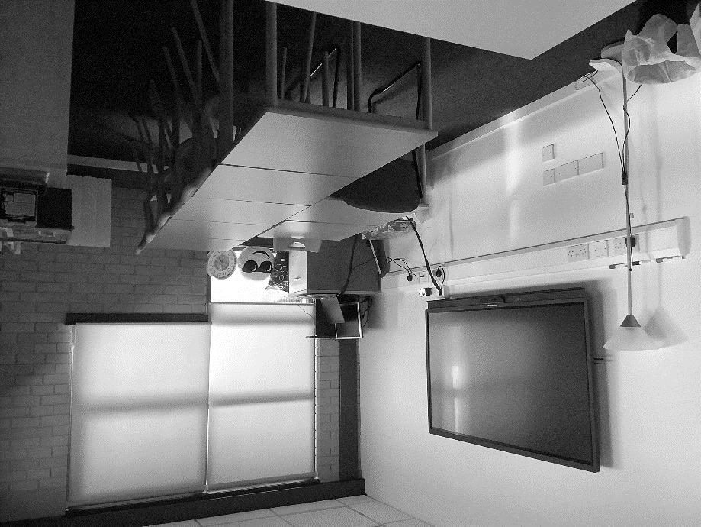
Students in S4, S5 and S6 work within the Senior Phase of the Curriculum which is focused on National Qualifications and experiences which prepare young people for life after school. All senior phase pupils within our service will choose four subjects to specialise in. From 2014 onwards, all pupils received SQA certifications based on new National Qualifications at National 3, National 4 and National 5. National 3 and National 4 are pass/fail courses with all of the assessment completed internally. Most courses have three units. The National 5 courses are graded A-D and assessment includes externally verified assessments plus an external exam. All internal assessment is subject to external verification.

Our Senior Phase Option Choice Form

Our Senior Phase option form is centred on the subjects that our on- site teaching staff have subject specialism. At times, Senior Phase students have requested to specialise in a subject out with our options form. Here, SWSS will liaise with the mainstream school to source a curriculum that can be followed by the young person with guidance from staff both within SWSS and the mainstream school. We offer our Senior Phase subjects from National 3 up to Advanced Higher. Furthermore, we offer National Progression Awards at Level 4 and 5. The service links in with the Senior Phase Programme offered to all mainstream schools in EDC. This provides an opportunity for our young people to choose a college based course. Those who choose this option will attend college two afternoons in the week. Through our joint venture with the Positive Achievements employability programme, an option for our young people is to gain vocational based qualifications such as manual handling, first aid and other industrially recognised qualifications that will support transition into this sector. Again, this course is of- site and young people attend two mornings in the week.
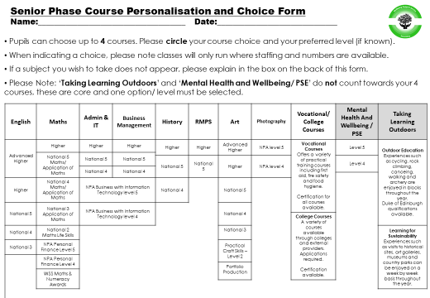

Homework.
As a service we are aware of the importance of home reinforcement of the work that is done through the school day. At all times we will encourage young people to participate in home reinforcement, will provide materials to support and encourage working at home but we will not enforce homework.
Through encouragement, displaying factual evidence and working with parents and carer’s we communicate the benefits of homework. However, we understand the difficulties and barriers that some of our young people face and their compartmentalised outlook on their life.
To correspond with SQA presentation and prelim examinations, we offer supported study to all our senior phase pupils to support their exam preparation. This will be done within the service building after the pupil school day. In addition, young people have the opportunity to use classrooms and resources at break times which will be supported by teaching staff.

Personal and Social Education Programme
A formal programme of personal and social development (PSE) is taught from S1-S6. Consisting of one weekly period, the course is taught by staff trained in PSE. Such programmes are designed to ensure that all pupils cover some aspects of social education not otherwise covered by individual subjects. Hence, during the four-year course, pupils will encounter aspects of careers and health education, the law, relationships, self-awareness and studying. Our parents and carers will be contacted prior to certain aspects of the course.
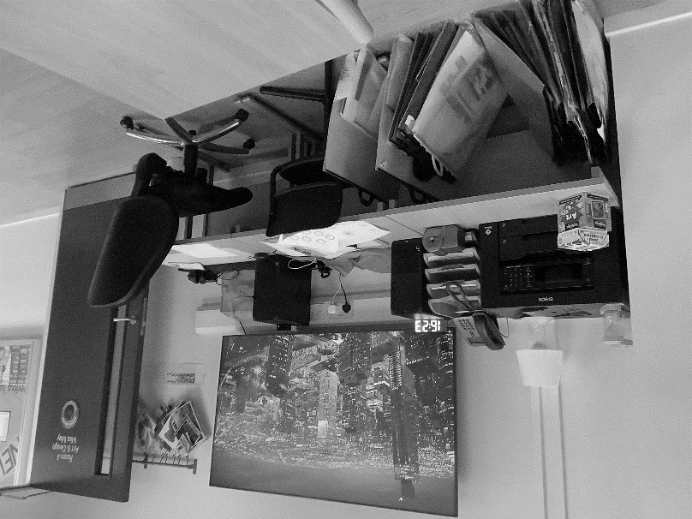
Mental Health, Wellbeing and Personal Development.
As a wellbeing resource we use our third period of the day as time for our young people to stop subject course work and focus on personal development and wellbeing. We encourage all our pupils to work on a daily planner for 15 minutes to record their moods, anxieties and their feelings. We use this to provide our young people with an opportunity in the day to reflect on themselves and for them to understand themselves better. Staff are on hand to support young people at this time. Furthermore, we use the rest of the period to provide an experience for the young people to develop a knowledge of Mental Health and Wellbeing or Personal Development tasks. Both these programmes are accredited and are used to supplement our subject course choice to five for our senior phase pupils.

Outdoor Education.
Every Wednesday our service provides an opportunity for our young people to participate in outdoor education. Our principle goal is to develop skills for life, learning and work but specifically socialisation. We offer to courses to our young people. Firstly, in conjunction with our joint venture partnership with Positive Achievements, we provide a rigorous, high energy and sporting experience that incorporates hill walking, kayaking, mountain biking and climbing. In addition, the young people have the opportunity to participate in Duke of Edinburgh award that is supported by our service with Positive Achievements. Secondly, we offer a programme that is centred around Learning for Sustainability which incorporates visiting local areas and attractions such as parks, museums, retail centres and events. Furthermore, we provide opportunities to do work experience, independent travel in- addition to less rigorous sporting activities. We firmly believe in the benefits outdoor education provides and the need for our young people to experience outdoors which evidence suggests is becoming a limited activity for modern young people.

Careers - Skills Development Scotland.


The Service’s Careers Adviser, Irene Travers, attends the service on a Monday. The Careers Adviser works closely with our Acting PT DYW Coordinator to support pupils to develop their Career Management Skills and make realistic, well informed career choices. She will provide information, advice and guidance to ensure that pupils have a plan in place for leaving school and successfully move onto a Positive Destination. In addition to one to one career interviews, the Careers Adviser meets with S1-S4 pupils through PSE classes which develop pupils’ understanding of the routes and pathways available to them when leaving school, how to make a good career decision and an introduction to My World of Work which is Skills Development Scotland’s online resource.

All senior phase pupils are met frequently to discuss next steps and will be supported to make decisions. It is important to realise that pupils have open access to the Careers Adviser when they decide they need advice. At relevant times we will have Enhanced Transition Meetings where a more holistic group will meet to support transition and next steps. We work closely with other partner agencies such as Local Area Coordinators who specialise with young people who have an ASD diagnosis and EDC Employability Team, No One Left Behind. They work with all transitioning young people who require extra support to move to a positive and sustained destination.

Parents too are welcome to contact the Careers Adviser for help if they feel their child needs advice. This can be done through the service, or by contacting the school’s Careers Adviser at Skills Development Scotland, New College Lanarkshire, 50 Southbank Road, Kirkintilloch, G66 1NH. The Careers Adviser will be in attendance at our Introduction Evening. Some useful websites for careers research:

www.myworldofwork.co.uk

https://www.mykidscareer.com

www.planitplus.net

www.prospects.ac.uk

www.apprentishipsinscotland.com

Please contact the Team Leader if you would like any further information about the curriculum within our service.

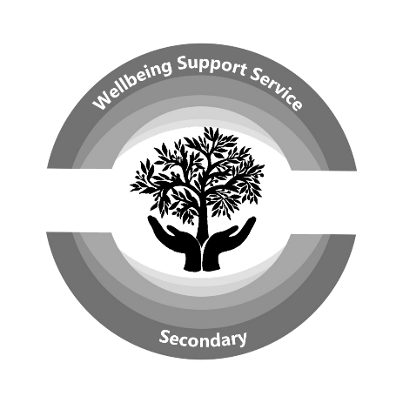

Assessment and Reporting

Liaising with and Involving Parents in their Child’s Education

The Education Service is keen to ensure that it involves all parents appropriately and sensitively in their child’s education. Under Education Law, “parents” include:

- Non-resident parents who are liable to maintain or have parental responsibilities in respect of a child;
- Carers who can be parents;
- Foster carers, relatives and friends who are caring for children under supervision arrangements;
- Close relatives, such as siblings or grandparents caring for children who are not “looked after and accommodated” by the local authority or are under home supervision (looked after) arrangements.

Everyone who is a “parent” (under Education Law) has the right to receive advice and information about their child’s education and take part in activities.
The Education Service will treat all parents equally. The exception to this is where there is a court order limiting an individual’s exercise of parental rights and responsibilities.
Schools collect information about a child’s family circumstances on an annual basis. Where family circumstances change during a school session, it is important that parents inform their child’s school of these changes.
Further information about how the Education Service seeks to work with parents is available in the publication Schools, “Parents” and “Parental Responsibility”: A briefing paper for schools and education support services under the management of East Dunbartonshire Council (2007).
This publication is available from schools or the Chief Education Officer who can be contacted at:

East Dunbartonshire Council
Southbank House
Strathkelvin Place
Kirkintilloch
G66 1XQ

Tel: 0300 123 4510
Email greg.bremner@eastdunbarton.gov.uk

Assessment
Assessment is a vital part of the educational process. Regular assessment enables teachers to evaluate pupils’ progress and to gauge if particular areas of work or skills have been mastered. Assessment tells teachers if their teaching has been effective and, depending on the results, indicates whether a class or an individual is ready to move on to the next area of work. The main aim of assessment is to support pupils in their learning by highlighting how much has been learned as well as what they have still to learn.
Target setting is widespread and by setting appropriate and realistic targets pupils gain a real sense of achievement when they are overtaken. Throughout the service a wide range of assessment strategies are employed. In addition to small tests at the end of units of work, teacher observation of pupils as they work, talking and listening, projects and homework, pupils are encouraged to engage in self-assessment and peer assessment so that they, as well as their teachers, may judge their progress.
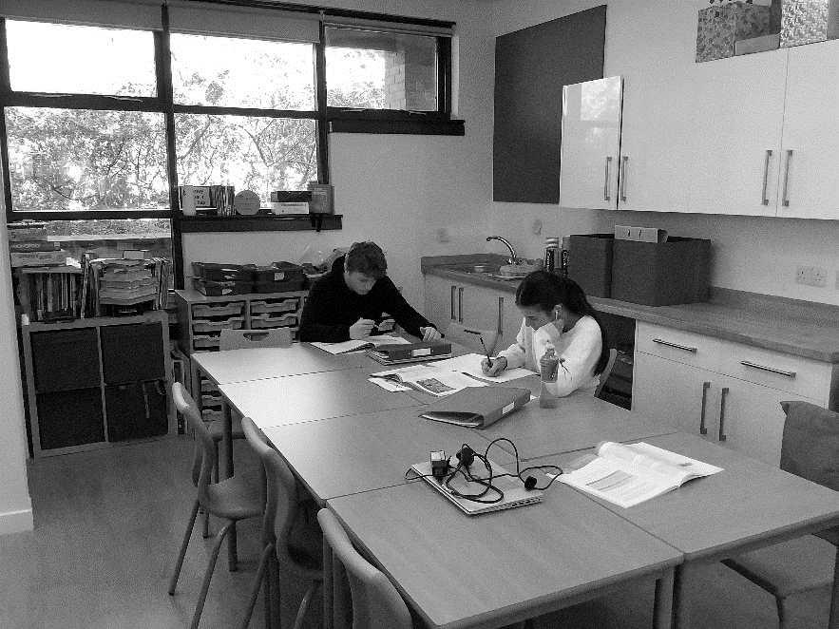
With the implementation of Curriculum for Excellence the progress of pupils in S1 and S2 will be measured against a menu of Experiences and Outcomes in each subject, and across subjects. There are four levels in CfE. The expectation is that most P7 pupils will have overtaken Levels 1 and 2 before embarking on their Secondary education and that the majority of pupils will overtake Levels 3 and 4 by the end of S3.

Reports to Parents
Reports (ILP) to parents are issued at the end of each term. We will provide a shorter interim report in October and March and a full curricular report in December and June. This gives the parents a general overview of the progress being gained for that term and year. Within the BGE ILP, we use a traffic Light system to show progress in class. In Senior Phase we use a Target Grade and Working Grade to provide a visual and simple feedback tool to show progress. In addition to written reports parents have the opportunity to meet with their child’s teachers at two consultation evenings in November and March. Any parent who is concerned about a child’s progress is welcome to contact the service at any time to discuss the matter. If you are unable to come to the service building you can telephone or write if you are concerned about any aspect of your child’s work.

National Qualifications
SWSS is a National Qualifications presenting centre, however, our young people will be presented through their mainstream school. Any young person not on a school roll will be presented by SWSS.

Support for Pupils
In East Dunbartonshire Council we have our Including Every Learner Policies – Promoting positive relationships and managing behaviour that challenges and Policy and provision for children and young people with additional support needs. These documents offer guidance and policy on ensuring the needs of all learners in our schools and early years’ centres are met.

Guiding Principles

- Presumption of mainstream includes a structure of universal and targeted support. This offers flexible access to both specialist support and mainstream schooling according to individual needs through a continuum of additional support needs provision
- Local, integrated and streamlined processes of assessment and decision making in full collaboration with learners and their families
- Increasing the capacity of staff to meet the needs of a broad range of learners at all levels of the continuum of support through Career Long Professional Learning (CLPL)
- Equity of access to Curriculum for Excellence through adaptations to the curriculum and learning environment to better meet the needs of all
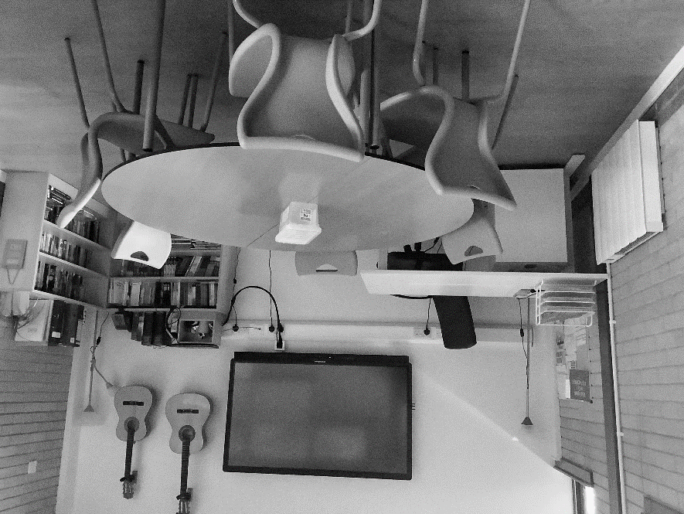
Universal and targeted planning for children and young people should be proactive and solution focussed. A whole school and classroom ethos and culture should include strategies that support all children.
Provision across all establishments focuses on developing and supporting the whole child and this includes having: safe and nurturing environments; strong relationships; an ethos of inclusion; emphasis on care and welfare; breadth of experience; and partnership working.
The curriculum within all early year’s centres, primary and secondary schools is focused on providing a meaningful, engaging and challenging experience for all learners. The curriculum in all sectors is based on the underlying principles of Curriculum for Excellence, which sets out an entitlement to access:

- A coherent curriculum from 3 to 18;
- A broad general education to the end of S3;
- A senior phase including qualifications;
- Opportunities for skills for life, learning and work with a focus on literacy, numeracy and health and wellbeing;
- Personal support to enable learners to gain as much as possible from the opportunities of Curriculum for Excellence; and
- Support in moving to a positive and sustained destination beyond school

East Dunbartonshire Council’s policies, procedures and practices relating to children and young people with additional support needs are in line with the Education (Additional Support for Learning) (Scotland) Act 2004 and the Education (Additional Support for Learning) (Scotland) Act 2009 which place duties on education authorities and provide rights for parents of children with additional support needs and young people with additional support needs. All children require support to help them learn. However, there are some children and young people who need some extra support or support which is a bit different from the support provided for all children to make sure they benefit from school education. That support may come from education services but can also be provided by a NHS Board, Social Work, Skills Development Scotland, or independent and voluntary organisations. Children and young people in school who need extra support or a different sort of support from what is generally available have additional support needs. These additional support needs can arise for lots of different reasons. The reasons why a child or young person may have additional support needs are too many to list here, however the following are examples:

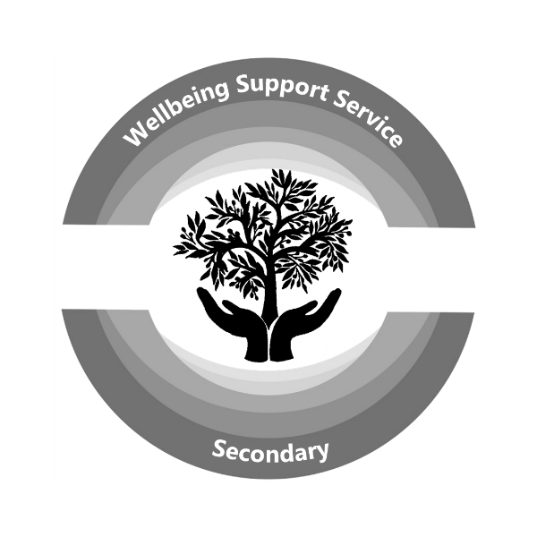
That the child or young person:
- finds it difficult to behave in school;
- is hearing or visually impaired;
- has a particular health need;
- is living with parents who have a drug or alcohol dependency;
- has English as an additional language;

Some additional support needs may only last for a short period of time and other additional support needs will be lifelong. If you think your child may have additional support needs, you should talk to your child’s school about this. All children and young people have their needs continuously assessed and reviewed. Your child’s school will be able to show you their assessment of your child’s needs and will send you copies of reports on how your child is progressing in school.

All schools in East Dunbartonshire look at children’s needs through a process of staged intervention.
This process allows teachers and others to
- identify those children who may need additional support;
- make plans to support those children identified;
- deliver the support the child requires; and
- regularly review the support provided.

The education authority has put in 3 stages of support: in summary, these are:

Universal Support - class/group based strategies.
Parent(s), staff or another agency identify a child/young person needing support or planning which can be met by the introduction of appropriate strategies by staff.

Targeted Support – whole establishment strategies
At Pupil Support Group Meetings or collaborative meetings, parent(s), staff or another agency identifies a child/young person needing support or planning which can be met by the introduction of appropriate strategies and the impact of these monitored. These strategies should take account of prior learning and may be developed in some instances with advice from and consultation with appropriate education support services. At this stage a wellbeing assessment must be undertaken and the child/young person’s views sought.
All pupils who are considered for Targeted Support, access this through their Pupil Support or Support for All Group. This ensures that staff comply with duties in CYP Act 2014 and ASL Act 2004, 2009. All assessments to determine the need for Targeted Support fully involve the views of the child and parents.

Targeted Intervention – whole establishment and other agencies.
At Pupil Support Group Meetings or collaborative meetings, parent(s), staff or another agency identifies a child/young person needing further support or planning from out with the existing pre-school or school setting and may involve other agencies in addition to appropriate education support services. East Dunbartonshire Council’s policy on Staged Intervention states that children, young persons and their parents should be fully involved in the staged intervention process. In addition, the 2004 Act places the education authority under a duty to ensure that parents and pupils are involved fully in discussions and decisions about their child’s learning. The 2004 Act gives parents the right to ask the education authority to find out if their child has additional support needs. Before making such a request however, it is expected that the parent will have explored the appropriateness of this with their child’s school as all educational establishments are responsible for implementing the Education Service’s staged approach to identifying learning and support needs. All schools within East Dunbartonshire Council follow a standardised framework for planning, recording and reviewing the additional support needs of individual pupils and schools (supported by parents and other agencies) are responsible for identifying, addressing and monitoring/reviewing the additional support needs of pupils.

The Education (Additional Support for Learning) Act 2004/2009 places duties on local authorities to provide access to independent mediation for resolving disputes with parents and carers of children and young people with additional support needs when or if they arise. East Dunbartonshire Council uses Resolve Scotland. For further information, contact: 0131 313 8844 or go www.resolve.org.uk.

Advocacy
Parents and eligible children/young persons also have the right to have a supporter or an advocate to present their case at any meeting with the school or Education Authority, in relation to the exercise of the Education Authority’s functions under the Education (Additional Support for Learning) (Scotland) Act 2004.
Parents, carers and children with additional support needs can also seek independent advice and support through:
- Scottish Independent Advocacy Alliance, www.siaa.org.uk, 0131 260 5380
- Take Note: National Advocacy Service for Additional Support Needs
- Barnardos (in association with the Scottish Child Law Centre) www.sclc.org.uk, 0131 667 6633.
My Rights My Say
Enquire: www.enquire.org.uk 0845 123 2303

School Counselling

Lifelink is the School Counselling provider for East Dunbartonshire Council. Having delivered counselling and groupwork services since 2022, Lifelink will continue with a similar suite of services from 1st August 2026 for two years, with the option of a further two-year extension thereafter. Services include universal 1:1 school-based counselling, groupwork and Holiday Support for pupils from 10 years of age. Schools have designated therapists assigned within a cluster-based model.

Supporting Families Service
The core purpose of this service is to provide support to families in developing their skills and confidence in their parenting and to provide services to children to enhance their development and learning. Examples of the services available include group parenting workshops, bespoke 1 to 1 support and advice. Services also include holiday a play scheme for children and young people with additional support needs as well as our Snack and Play holiday programmes for children who meet certain criteria. If you wish to find out more about any of the services please contact the team by emailing: parenting@eastdunbarton.gov.uk A member of the team will be in touch. Further information can be found on website Parent and family learning- East Dunbartonshire Council

Support for Learning Services

Education staff have an excellent understanding of their learners, any barriers to learning and how to support them. They provide individual educational programmes designed to meet their specific needs and are continually looking at ways to develop practice to improve outcomes. This cycle of planning, review and evaluation is likely to include strong partnership working with a range of more specialised services which can provide advice and targeted support as necessary.

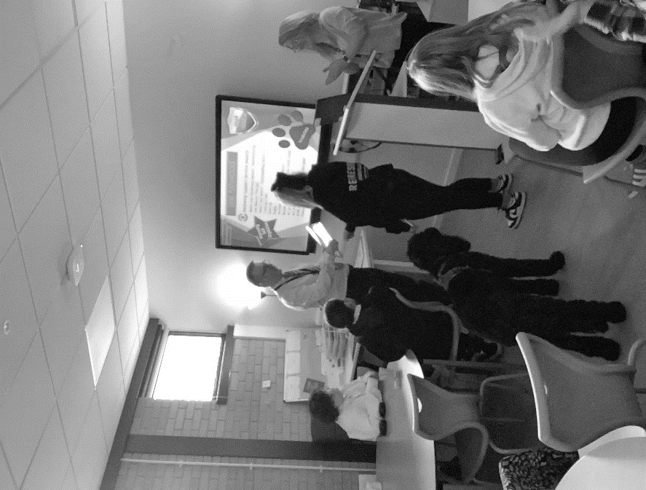
Some learners benefit from a timetable that offers a combination of access to specialist support and mainstream. This type of support is offered from primary to secondary stages. The balance of mainstream to specialist support is based entirely on the assessment of the profile of learning needs.
East Dunbartonshire Council has a continuum of support for learners requiring targeted support, these are reviewed and planned for each individual alongside professionals, parents and the child/young person themselves – TAC (Team around the Child).
Learners who may require to additional resources could be experiencing:
- specific language difficulties (expressive or receptive)
- difficulties in the area of social communication
- significant difficulties with focus and attention
- significant learning needs
- self-regulation and self-care needs

For some learners, additional support is required from other specialist resources which offer outreach support. Requests for outreach to support the child within their mainstream school are made to the Locality Liaison Groups (LLGs).
There are two LLGs –
- the localities of Bearsden, Milngavie and Bishopbriggs
- the localities of Lenzie and Kirkintilloch.

The purpose of the LLG is to allocate outreach services to support current placements in mainstream.

Outreach support
Outreach support involves a specialist teacher becoming involved with a learner for a time-limited period. This is a short term targeted intervention approach to re- engage a young person with their mainstream school. This includes delivering services from a mainstream school, an East Dunbartonshire Council Building, delivering services from the premises of a partner agency and home visiting.

SUPPORT FOR PUPILS - Service Provision
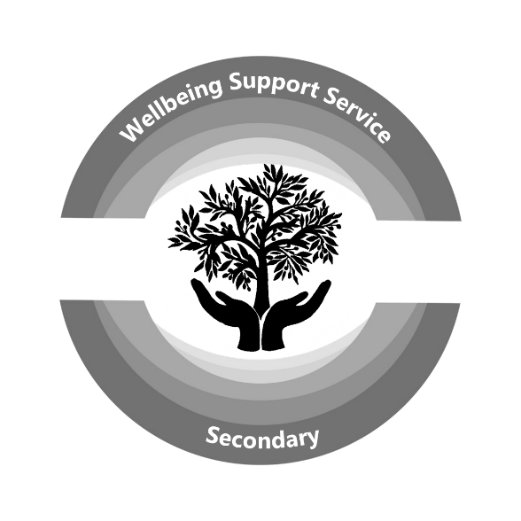
SWSS staff work closely with mainstream schools to gather information on all pupils, and, in particular, to identify those who may need additional support. This information, along with important medical advice, is summarised and circulated to all staff. A process of Staged Intervention is used to meet the learning needs of all pupils. Class teachers, and then Principal Teachers, try to meet the needs of any pupil in their care by adopting the usual strategies of support including additional or alternative presentation of materials or direct or targeted tuition. If additional support is required, then input from specialised services or internal teaching staff will happen. After consultation, support will be provided in one of several ways: pupil support assistants may accompany pupils to classes to ensure that any particular difficulty faced by the pupil is overcome; teaching staff may work cooperatively in classes to support the learning of individuals or small groups, or may assist with the differentiation of subject materials. All forms of support offered are reviewed regularly, and may be adjusted depending on the needs of the pupils and/or the wishes of parents. SWSS teaching staff may also be asked to investigate difficulties being faced by pupils in their learning. This usually involves some assessment of basic literacy skills and will only be undertaken at the request of parents and in consultation with the pupil’s teachers and mainstream school. It may also be necessary to seek a consultation meeting with the school’s Educational Psychologist to ensure a comprehensive investigation of the situation. Permission from parents for such a meeting is always sought in advance. Alternative assessment arrangements can be made for pupils who have additional support needs. Subject teachers will gather robust evidence and liaise with mainstream school so that pupils are given appropriate support.

East Dunbartonshire Council in supporting inclusion in SWSS has also established and developed a number of support for learning services: These are –
• English as an Additional Language Service
• Language and Communications Service
• Sensory Service (Visual and hearing impairment)

These are a team of specially trained teachers who undertake different roles to the school. These services support pupils through –
• Consultancy
• Continuing Professional Development
• Co-operative Teaching
• Curriculum Development
• Partnership Working

Further information is available from the senior managers who can be contacted via the service or mainstream school.

Psychological Services
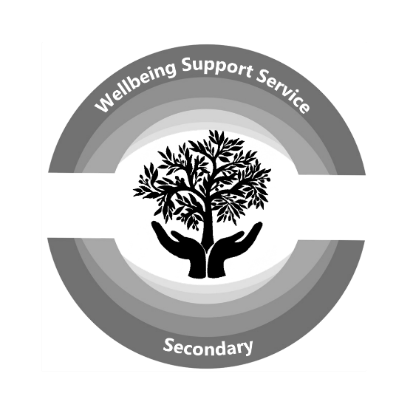
In some cases, the expertise of the Psychological Services may be requested to help analyse the cause of particular support needs and to offer advice to the pupil, parent and the school on how to cater for any additional support needs. A link Educational Psychologist from the Council’s Psychological Service will supports us in delivering East Dunbartonshire’s policy for identifying, assessing and supporting all pupils, particularly those with additional support needs. The Psychological Service operates at three levels within the Council, namely that of the individual young person/family, the level of the whole school and that of the Authority. SWSS has no formal link Educational Psychologist (EP) but works with the relevant EP from the mainstream school. Educational Psychologist works collaboratively with SWSS leadership at all stages of intervention with regard to individual pupils, groups of pupils or relevant topics related to the school improvement plan.

Conversation Logs
In our service, pupils are taught by a number of different teachers. In order to ensure that each pupil knows and is known well by at least one member of staff, a member of our team work will work individually with our young people. This work ensures as a service we can support all our young people with their emotional, curricular and pastoral welfare.
Throughout each term, conversations are arranged that provides an opportunity for the young person to discuss and highlight their successes areas of concerns and reflect on their placement and next steps. This bi- directional conversation enables the service to provide feedback and discuss areas of concern that are hindering progress in addition to highlighting success.

Health and Wellbeing Planning.
Smart simple targets have frequently been highlighted as a successful approach to building self-confidence and self-esteem. As a service we use this approach to provide the pupil the opportunity to reflect, review and plan with a member of staff the barriers to their health and wellbeing that they face and try to overcome. Fortnightly, our team meet together to provide feedback and opinion on all aspects of a young person’s conduct, work ethic, communication and progress in emotional and physical wellbeing. The process is outlined below.

- All staff
- focus on previous set HWB targets and discuss if achieved
- provides a summary of their perception on pupil’s current emotional health and wellbeing within their class and service environment
- discuss strengths and next steps for pupil using GIRFEC Questions to suggest possible targets to support mental health and physical wellbeing.
- Member of staff and pupil meet to complete a Health and wellbeing assessment and discuss teaching staff’s feedback.
- Staff and pupil jointly create new SMART Targets.
- This process runs in a cycle and approximately termly
- Service provides a termly report on health and wellbeing incorporating planning targets for young person to family and mainstream school.

Pastoral Support
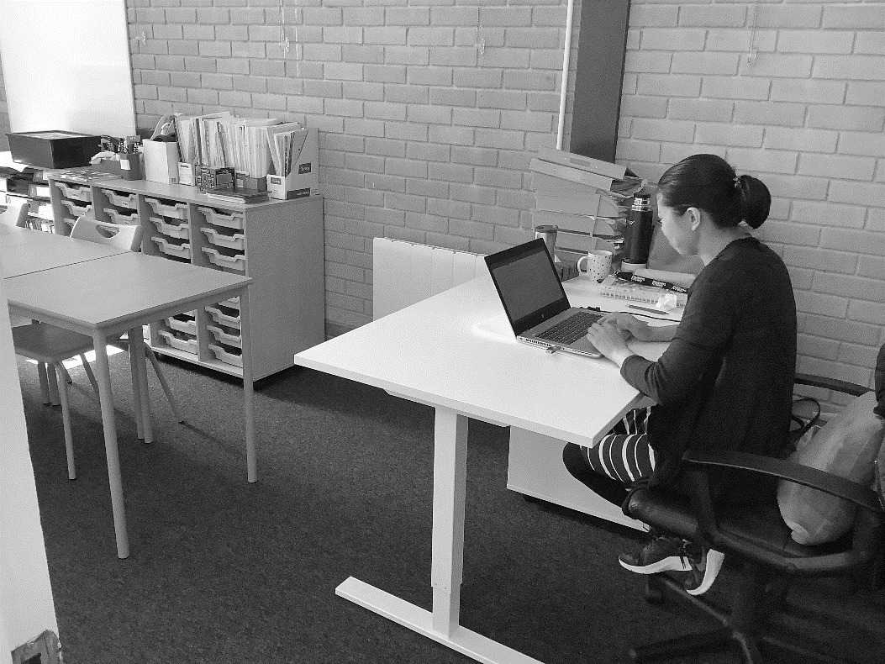
Every pupil at SWSS remains on the roll of their mainstream school and so, SWSS will use Pastoral Support Teams within the various schools as a useful contact. SWSS has no formal Pastoral Care Team, however, all SWSS staff have a duty of care and are First Line Guidance. Our Pastoral responsibilities are enhanced through our Team Leader who takes on the responsibility of Pupil Welfare. Other members of the SWSS staff provide assistance through getting to know the young person during their time here and counsel individuals who find difficulty in adapting to the demands of living and working in a school environment.
During the Session pastoral notes will be kept to cover:
- pastoral care
- meetings
- consultation on health, personal, social and educational problems
- attendance

Other staff, in particular, PT DYW Coordinator will be available at other times to provide first class expertise for options and career advice.
Parents wishing to enquire about the progress of their son/daughter or any problem relating to service should initially contact the school office to arrange an appointment with Team Leader or Principal Teacher.

Team Around the Child (TaC)
The service frequently participates in TaC meetings to support our young people and meet with other professionals and families. TaC groups are called by mainstream schools, and SWSS will participate as a partner agency. The TaC ensures that all pupils are gaining the maximum benefit from education.

Wellbeing, Protecting and Safeguarding Children and Young People
In 2026, National Guidance and the East Dunbartonshire Child Protection Procedures (PM 3/21) adopted a strengths-based approach incorporating children’s views and ensuring effective collaboration with families.
The guidance embeds the UNCRC, the Promise and principles of GIRFEC as part of the continuum of preventative and protective support.
“Abuse and neglect are forms of maltreatment. Abuse or neglect may involve inflicting harm or failing to act to prevent harm. Children may be maltreated at home; within a family or peer network; in care placements; institutions or community settings; and in the online and digital environment. Those responsible may be previously unknown or familiar, or in positions of trust. They may be family members. Children may be harmed pre-birth, for instance by domestic abuse of a mother or through parental alcohol and drug use”.
(National Child Protection Guidance, 2021, p.12)

Within East Dunbartonshire, all adults have a shared responsibility to keep children and young people safe and as far as possible, protection from abuse, neglect, and exploitation. Children need support to keep themselves safe. Adults and professionals must work together with families and carers to enable children and young people to grow up in a safe and secure environment.
The Child Protection officer in school will be either the head teacher or depute head teacher and there are clear processes in place to enable practitioners, or others to report any aspect of suspected abuse or maltreatment.

Education staff are required to assist in the protection of children by:
- Creating and maintaining a positive and caring ethos
- Developing health and personal safety programmes
- Being observant of children’s needs, views, and concerns
- Reporting and recording concerns about the welfare or safety of children
- Monitoring and supporting children in co-operation with relevant professionals, parents and carers.

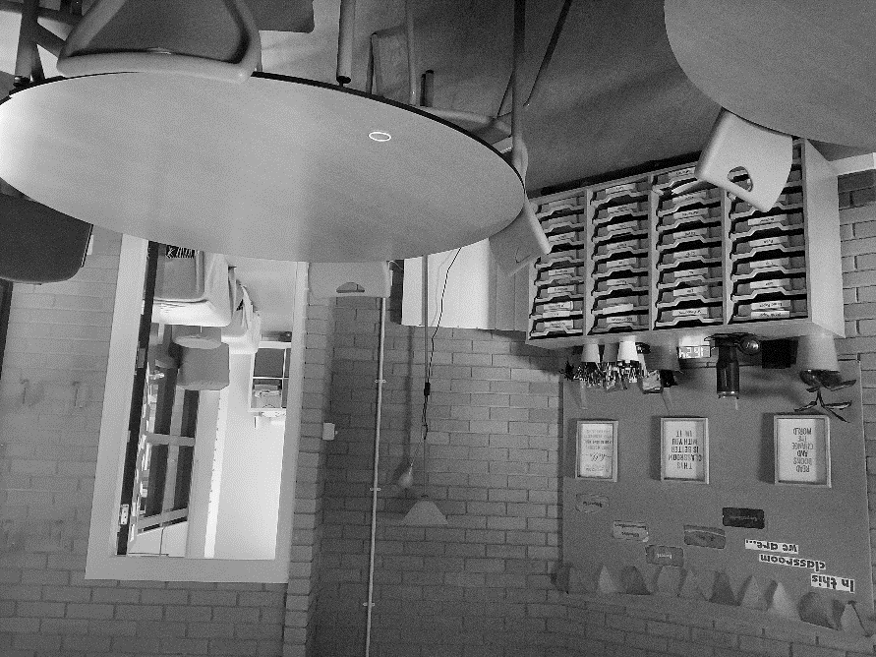
Education staff cannot keep secret any allegations or concerns about child abuse, even if a child or adult request this. Information or concerns that a child may be at risk of harm must be passed on to protect the child or young person. Staff will always treat the matter sensitively, and with dignity and information will only be passed to those who need to know to protect and support the child or young person.
If parents or others have concerns for any child, they can speak to the Head Teacher/Child Protection Officer about this. They can also contact social work services and/or the police.
When a member of staff, a child or another individual provides information and the Head Teacher considers that there is a possibility that a child has been harmed or is at risk of harm, the Head Teacher is required to immediately contact social work services to discuss the circumstances and agree the immediate action to be taken. School staff are then required to co-operate with any subsequent enquiries or support plans.
Every education establishment or service has copies of the East Dunbartonshire Council Child Protection Procedures and Guidance. These are available for reference from the Head Teacher.
Child Protection and Safeguarding
Abuse and neglect are forms of maltreatment of a child. Somebody may abuse or neglect a child by inflicting, or by failing to act to prevent, significant harm to the child. Children may be abused in a family or in an institutional setting, by those known to them or, more rarely, by a stranger. “Child protection‟ means protecting a child from child abuse or neglect. If a child’s wellbeing is considered to be at risk, relevant information must always be shared. It is our public responsibility to protect children.
Anyone who suspects child abuse or neglect should contact East Dunbartonshire Council Social Work Advice and Response on 0141-777 3000, or the Police. Each school has a designated Child Protection Coordinator, who will work with other professionals, children and where appropriate, families to safeguard children. The name of the Child Protection Coordinator should be displayed prominently within the school.

In SWSS the Child Protection Coordinator is Mr P Quinn (Team Leader)

Getting It Right for Every Child (GIRFEC)

The Scottish Government introduced Getting It Right for Every Child (GIRFEC) as a programme of change, reaching across all children and adult services in the public and voluntary sectors in Scotland, to achieve better futures for all of our children, young people and their families. It builds from universal health and education services and drives the developments that will improve outcomes for all children and young people. We want all our children and young people to be fully supported as they grow and develop into:
- successful learners
- confident individuals
- effective contributors and
- responsible citizens.

We believe they should be:

Safe, Healthy, Active, Nurtured, Achieving, Respected, Responsible and Included.

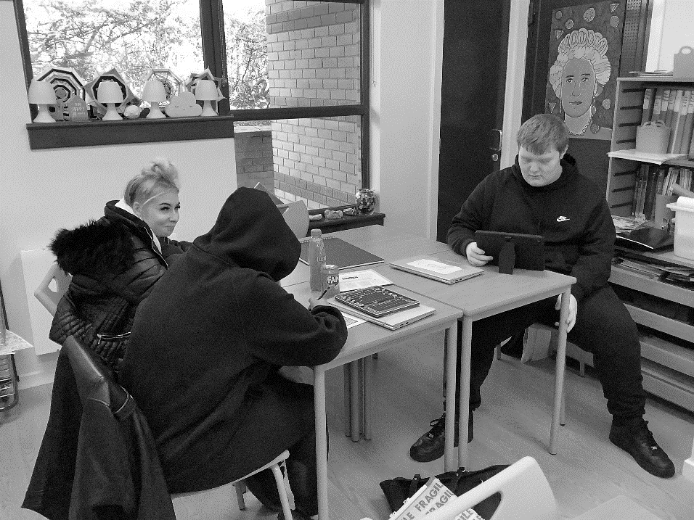
These are the eight indicators of wellbeing.

The Getting It Right approach is about how practitioners across all services for children and adults meet the needs of children and young people, working together where necessary to ensure they reach their full potential. This approach, based on the United Nations Convention for the Rights of the Child, is
- Child focussed, ensuring that the child and family are at the heart of decisions and supports;
- Based on a holistic understanding of wellbeing;
- Early interventionist to tackle needs as soon as they appear;
- Joined up, to ensure services work together. It is the entitlement of every child to be supported throughout their education.

It is the entitlement of every child to be supported throughout their education. The EDC Including Every Learner Policy provides a continuum of support from universal to targeted and ensures practice is underpinned by a shared understanding of wellbeing and in the dignity and worth of every individual child/young person. This is in line with GIRFEC National Practice Model.
Teachers plan experiences and assess progress in learning, and for most children this is sufficient. From time to time, however, approximately one fifth of learners may experience developmental or environmental difficulties which impact on their ability to learn. For most, modifications can minimise the impact of such difficulties and learning can proceed. These modifications are described as differentiation and in most cases teachers will differentiate as part of normal teaching and learning, without the need for intervention from promoted staff.
Within East Dunbartonshire schools, teachers employ the following model to provide a clear, structured pathway for learners,
- Modifying Content – use of learning materials at different levels;
- Modifying Process – varying the length of time children take to complete a task;
- Modifying Product – giving children choice in how to express ideas or required learning;
- Modifying Learning Environment – giving children areas to work which suit their learning styles.

Staff record differentiated approaches in their short and long term plans and ensure that the results of differentiation are clearly documented within evaluations of teaching and learning. Where intended progress does not take place, the child/young person’s needs are considered following a model of staged intervention.
When a wellbeing concern has been brought to their attention, the pupil support coordinator will consider the following questions in relation to the eight wellbeing indicators;
- What is getting in the way of this child or young person’s wellbeing?
- Do I have all the information I need to help this child or young person?
- What can I do now to help this child or young person?
- What can my agency do to help this child or young person?
- What additional help, if any, may be needed from others?

All pupils who are considered for Targeted Support, access this through their Pupil Support or Support for All Group. This ensures that staff comply with duties in CYP Act 2014 and ASL Act 2004, 2009.
All assessments to determine the need for Targeted Support fully involve the views of the child and parents.

School Improvement

SWSS is part of East Dunbartonshire Council’s Education Department ASN Provision. As with all educational services in East Dunbartonshire, we are committed to providing a first class service that meets the needs of all our young people and their family. We provide a yearly plan that highlights our areas of priority established through our self-evaluation and quality assurance process. Our plan coincides with both the Education Improvement Plan and ASN Provision Improvement Planning.

Service Improvement 2025-26

Improvement Plan Priority 1: Health and Wellbeing

What progress have we made (Impact)? What evidence do we have to support this?
- Children, young people and the wider school community know about and understand the United Nations Convention on the Rights of the Child and can share how it impacts on their lives and on the lives of children everywhere.
- UNCRC working group has delivered CLPL to staff to support achievement of Silver RRSA Award.
- Using school display boards to provide a monthly UNCRC message
- Delivering workshops to both BGE and SP pupils to increase awareness of rights to young people within SWSS
- Monthly ‘Rights around the world’ presentation from pupil steering group at Chat & Chomp.
- Promotion of rights through engagement of SWSS community in key events such as ABW, LGBT+ and Holocaust Memorial Day and others
- Monthly student council
- Promote and produce pupil friendly policies and guidance to support pupil engagement and sense of belonging
- Implementation of a second Parent Consultation Evening
- Use of Conversation Log and Health and Wellbeing Planning to allow young people to reflect and review their progress
- Ongoing review, update and development of PSE, MHWB and PD courses to inform and meet the needs of our young people.

Improvement Plan Priority 2: Attainment and Achievement

What progress have we made (Impact)? What evidence do we have to support this?
- Alternative Practical Learning Experience for S1 targeted pupils is in place and working well for all participating pupils
- What does excellent learning look like in SWSS toolkit is completed and will be introduced session 26-27 for quality assurance purposes.
- Attendance and Engagement monitoring tool in place and implemented into service practice providing feedback to service users
- Staff in literacy and numeracy have reached out to other services to develop SWSS approaches to literacy and numeracy learning and teaching.

Improvement Plan Priority 3: Transitions

What progress have we made (Impact)? What evidence do we have to support this?
- Developed and sustained current links with partners to enhance work experience opportunities for some SP pupils
- Strong links with SDS to ensure transition planning for all senior phase pupils and forward planning for BGE pupils
- Wider achievement opportunities for all pupils
- Successful learning for sustainability programme developing vocational, practical and life skills

Literacy Development
Reading
Senior Phase
- Our reading focus centres on critical literacy, analytical evaluation of complex texts, and decoding specialised vocabulary across subject disciplines to support SQA attainment.
BGE
- Regular trips to the library are now incorporated into lessons
- Environmental Reading: Rather than formal comprehensions, staff are using informal, side-by-side teaching during very brief, low-stakes interactions. Assessing reading capability using environmental print, highly visual texts, or high-interest graphic novels reduced has lessened anxiety around reading.
- Phonics Re-intervention: For pupils verified at Level 1, we are bypassing standard secondary texts to introduce age-appropriate, high-interest/low-reading-age (Hi-Lo) books combined with structured, synthetic phonics toolkits (such as Barrington Stoke titles).
- The Nurture Classroom Approach: Classrooms must mirror the low-arousal, safe environments where reading is integrated into predictable, comfortable routines rather than high-pressure silent reading slots.
Writing
Senior Phase
- A focus set on pupils mastering structured discursive and analytical essays
BGE
- To establish base levels without triggering avoidance or emotional outbursts, we are temporarily removing the physical demand of writing:
  - Laptops are used for longer pieces of writing.
  - Visual Storyboarding: Utilising pictorial sequencing and matching exercises to gauge organisational and chronological skills (Level 1/2 milestones) without requiring extended text production.
  - Subject teachers across the curriculum are adapting their teaching styles from "extended writing" to writing that is scaffolded. Writing frames, sentence starters, and cloze passages are used. Writing is broken down into manageable tasks designed to build confidence through completing achievable tasks.
Talking and Listening
- Nurturing approach to Talking: Adopting structured check-ins and check-outs that simulate the nurture-base framework. This provides a highly predictable, safe structure where pupils practise active listening and basic turn-taking.
- Oral Baseline Verification: Staff use a variety of verbal questioning during tasks to evaluate understanding of concepts.
- Visual and Concrete Prompts: Emotion cards, props, and collaborative play-based learning models are used to reduce linguistic demands, gradually scaffolding pupils toward expressive communication.

Numeracy Development
To support our young people, the BGE curriculum was adapted and differentiated across three core Broad General Education organisers:
- Number, Money, and Measure
- Shape, Position, and Movement
- Information Handling
Our BGE curricular approach remains highly flexible to accommodate the diverse cognitive and emotional needs of our learners. Pupils worked through targeted areas within First, Second, and Third Levels. This targeted approach aimed to solidify foundational skills, ensuring learners develop the necessary understanding to interpret mathematical concepts and communicate their solutions clearly.
Robust diagnostic and engagement strategies were implemented:
- Maths Recovery Interventions: Used to establish baseline levels, identify specific gaps, and implement targeted support measures.
- Game-Based Learning: Utilized effectively to break down barriers to learning and significantly improve pupil engagement.
Pupils actively engaged with a variety of numeracy activities, concrete resources, and digital platforms. Key strategies included:
- Concrete and Pictorial Learning: Highly effective use of Numicon, mathematical starters, and interactive "Hit the Button" activities. Pupils successfully connected mathematical vocabulary to concrete and pictorial representations.
- Digital and Resource-Based Learning: Platforms such as Sumdog and Mathsframe, alongside targeted problem-solving worksheets, successfully maintained high engagement levels.
- Real-Life Contextualization: * Money: Introduction of financial education through recognizing notes/coins and participating in experiential "classroom shopping" simulations to practice calculating change.
  - Measure: Application of weighing and measuring skills through practical contexts (e.g., hospitality/baking). This highlighted the real-world impact of measurement errors and reinforced the importance of accuracy.
- Visual Supports: Environmental displays featuring new terminology and mathematical formulae were introduced to scaffold independent learning.
- By using learning logs, pupils better understand their areas for growth. This opens up a dialogue for progression and directly informs instructional planning.

Service Improvement Plan 2026-27

Improvement Plan Priority 1: Wellbeing and Inclusion

- SWSS UNCRC Working Group to continue to resource and develop material to support SWSS policy
- Promote and produce pupil friendly policies and guidance to support pupil engagement and sense of belonging
- To use ASN Leadership seminars to highlight new policy and practice and use this to implement improvement in service provision
- To review and update school handbook and to create a usable version for everyday use for staff and young people.
- To establish approaches that promote parental engagement with service activities
- Staff to participate in EDC Trauma informed training and other CLPL activities
- Review and continue to complete Conversation Logs and Health and Wellbeing Planning tools to support the needs of our Young People
- Continue to review, update and implement new material within our PSHE, MHWB and PD courses
- To seek new partnerships that will support wellbeing and Inclusion
- Implement new school day to support wellbeing

Improvement Plan Priority 2: Pedagogy and Meta- Skills

- To continue and develop service career provision.
- To create service career policy
- To develop and sustain current links with career partners and make new partnerships to develop work experience opportunities for all our young people in senior phase
- Implement and use “What does excellent learning look like at SWSS”
- Implement SWSS literacy plan and use EDC Literacy Hub when available to upskill staff in literacy support for Learners’
- Implement SWSS numeracy plan
- Implement and promote the awareness and use of meta- skills.

A copy of the Service Improvement Plan can be found on our website along with our Standards and Quality Report

Transferring Educational Data about Pupils

DATA PROTECTION ACT 2018

East Dunbartonshire Council will process your child’s personal data in compliance with the Data Protection Act 2018 and all other relevant legislation. The Council may share your child’s personal data with other Council services and public agencies to support the delivery of services to promote the health, safety and well-being of children and young people. For full details of how we will use your data please visit - www.eastdunbarton.gov.uk/council/privacy-notices

ACCESSING YOUR CHILD’S PUPIL RECORDS
Parents have a legal right of access to their child’s core education records, regardless of the age of their child. These are the records held within your child’s Personal Pupil Record (PPR). Parents do not have a general right of access to all records that mention their child. To access your child’s file, please apply in writing to the Head Teacher.

A child has a legal right of access to all records held about them. This includes records that may be held out with of the PPR. If a child is aged 12 or over and can show suitable maturity and understanding they may exercise this right of access through a request to the Head Teacher in writing. If your child is aged 11 or younger, or is not considered to have suitable maturity or understanding, then a parent may make an application on their child’s behalf for access to all records. The table below summarises who may access what records through writing to the appropriate Head Teacher.

AGE OF CHILD | CHILD’S LEGAL RIGHTS | PARENT’S LEGAL RIGHTS
Under 12 | A child’s parent or guardian may apply on the child’s behalf for access to all records | Right of access to core education record (PPR)
12 and older | If able to show suitable maturity and understanding, the child may apply for access to all records | Right of access to core education record (PPR)  No legal right to all records unless acting as child’s representative because child is unable to show suitable maturity or understanding

FREEDOM OF INFORMATION (SCOTLAND) ACT 2002
The Freedom of Information (Scotland) Act gives individuals a statutory right to the unpublished “internal” information and records held by Scottish Public Authorities such as East Dunbartonshire Council and its schools. Individuals have already used this legislation to find out about policy, procedures and how particular decisions have been reached. If you would like to use this legislation to access particular information please write to the Head Teacher, and subject to certain conditions and exemptions, you will receive a full response within twenty working days of receipt of the request.

Please note that you cannot access personal information on staff or pupils under this legislation. To access personal information about your own child, please see the section on Accessing Your Child’s Pupil Records.

The ScotXed Programme

Education Authorities, the Scottish Government and its partners have, for many years, collected information about pupils on paper forms. The information is now transferred electronically through the ScotXed programme.

The following explanation has been provided directly by ScotXed:
The Scottish Government and its partners collect and use information about pupils in schools (e.g. the number and characteristics of pupils, their attendance, absence and exclusions, their attainment and their destination when leaving school) to help to improve education across Scotland. This note explains why we need this information, how we use it and what we do to protect the information supplied to us.

Why do we need your data?

In order to make the best decisions about how to improve our education service, Scottish Government, education authorities and other partners such as the SQA and Skills Development Scotland need accurate, up-to-date data about our pupils. We are keen to help all our pupils do well in all aspects of school life and achieve better examination results. Accurate and up-to-date data allows us to:

- plan and deliver better policies for the benefit of all pupils
- plan and deliver better policies for the benefit of specific groups of pupils
- better understand some of the factors which influence pupil attainment and achievement
- share good practice
- target resources better
- enhance the quality of research to improve the lives of young people in Scotland

Data policy
Information about pupils’ education is collected through our statistical surveys in partnership between the Scottish Government and Local Authorities through the ScotXed Programme which aims to help schools and Local Authorities by supporting efficient collection, processing and dissemination of statistical information. The Scottish Government then provides analysis of the data to support research, planning, management and monitoring of education services as well as to produce National Statistics publications.

Education data within Scottish Government is managed effectively by secure systems and is exploited as a valuable corporate resource, subject to confidentiality restraints. As part of its data policy, Scottish Government will not publish or make publicly available any information that allows individual pupils to be identified, nor will data be used by Scottish Government to take any actions in respect of individuals. Data is held securely and no information on individual pupils can or would be made publicly available by Scottish Government.

The individual data about pupils in schools collected by Scottish Government through statistical surveys is used only for the statistical and research purposes for which it is collected.

Your data protection rights
The collection, transfer, processing and sharing of ScotXed data is done in accordance with the Data Protection Act (2018). We also comply with the National Statistics Code of Practice requirements and other legislation related to safeguarding the confidentiality of data. The Data Protection Act gives you the right to know how we will use your data. This note can give only a brief description of how we use data. Fuller details of each individual ScotXed survey, including the purpose of each and the published data, can be found on the ScotXed website http://www.gov.scot/Topics/Statistics/ScotXed
Pupil names and addresses (other than postcode) are never collected in any ScotXed statistical survey.

Scottish Government works with a range of partners including Education Scotland, Skills Development Scotland and the SQA. On occasion, in order to help meet our aim of improving the life of young people in Scotland, we may make individual data available to partners such as the National Registers of Scotland to carry out research relating to the national population census and also to academic institutions and organisations to carry out additional research and statistical analysis which helps inform policy development and contributes to improving outcomes for Scotland’s people. In order to carry out this research to support better decisions, policy making and practice, data may be linked to information from other sources.
Any sharing or linkage of data will be done under the strict control of Scottish Government, and will be consistent with our data policy and the National Data Linkage Guiding Principles. This will ensure that no individual level data will be made public as a result of the data sharing and that these data will not be used to take any actions in respect of an individual. Decisions on the sharing or linkage of data will be taken in consultation with relevant colleagues and individuals within and outwith Scottish Government. At all times pupils’ rights under the Data Protection Act and other relevant legislation will be ensured.

Concerns
If you have any concerns about the ScotXed data collections you can email the Head of Schools Analysis, Mick Wilson, at mick.wilson@scotland.gsi.gov.uk or write to Education Analytical Services, Area 2D, Victoria Quay, Leith, EH6 6QQ.

School Policies and Practical Information

The following service policies are available on our website
www.secondarywellbeing.e-dunbarton.sch.uk

- Child Protection and Safeguarding
- Relationship Policy
- Anti- bullying
- Dress code
- Learning, Teaching and Assessment

INFORMATION IN EMERGENCIES
We make every effort to maintain a full educational service, but on some occasions circumstances arise which lead to disruption. Schools may be affected by, for example, severe weather, temporary interruption of transport, power failures or difficulties of fuel supply. In such cases we shall do all we can to let you know about the details of closure or re-opening. We shall keep you in touch by using text alerts, letters, notices in local shops and community centres, announcements in local churches and announcements in the press and on local radio. If an emergency occurs and we can no longer use our building, our Muster site is
SOUTHBANK HOUSE, 1 Strathkelvin Pl, Kirkintilloch, Glasgow G66 1XQ

Parental Communication with School in Case of Emergency
It is important that parents keep in contact with the service to make us aware of any emergency situation or change of plans that will require contact with transport.

HEALTH
In the course of the school year immunisations will occur. Parents and the service are notified by the Greater Glasgow Health Board of all the times of the immunisation that are planned. Immunisations will be delivered by a nursing team from the NHS on- site. Young people or their families have the option to decline the immunisation arranged but should consult with their doctor for an alternative time. It is essential that parents inform the service of any changes to particular medical requirements of the children or of any medical condition which may affect their daily lives in the school or ability to receive the immunisation e.g. diabetes. If a child takes ill at school every effort is made to contact parents and therefore it is important that emergency telephone numbers be available to staff. Where a child has to be taken home, contact is necessary either with the parent or with a responsible adult named by the parent.

MEDICATION
If your child uses medication or uses an inhaler and requires to do so during school hours, a signed note should be sent to the office detailing doses, etc. All medicines should be retained by the pupil or where appropriate in the school office labelled with the pupil’s name. Parents should provide the Head Teacher with sufficient information about their child’s health care needs and treatment. Where necessary, this information should be updated annually or more frequently if there is a change in circumstances. Where there is concern about whether the school can meet the pupil’s needs or where the parents’ expectations appear unreasonable, the Head Teacher should seek advice from the school nurse or doctor and, if required, the Head of Education.

EDUCATION MAINTENANCE ALLOWANCE (EMA)

The Scottish Government has introduced the Education Maintenance Allowance (EMA) Scheme to encourage access to, and participation in further and higher education. If you are 16 years of age or over before 30 September 2020, you may be eligible for an EMA from the beginning of the school Term. This weekly allowance will be payable by East Dunbartonshire Council to students who attend a school managed by the Council, regardless of where they live. The SWSS will happily support a young person obtain and manage their allowance, however, Application forms and information will be obtained from the relevant mainstream school office or telephone 03001234510 or www.eastdunbarton.gov.uk

Catering Facilities

Unfortunately, SWSS has no on- site kitchens to provide school meals or snacks. Facilities within the service building are available for young people to dine at a table to consume their own food and beverages. With the service being within the vicinity of Kirkintilloch centre, many shops are available for young people to purchase food and beverages. The young people can use heating appliances within the building to re- heat food under supervision of staff

FREE SCHOOL MEALS (FSM)

Some families may be eligible for FSM. Children of parents receiving income support or income based job seekers allowance are entitled to a free midday meal. Children of parents who are in receipt of child tax credit or working tax credit and child tax credit or employment and support allowance (income related) or support under part IV of the immigration and asylum act 1999, may also be eligible. Information and application forms for FSM may be obtained from mainstream schools, the Community Hubs and the education office or www.eastdunbarton.gov.uk.

Pupils entitled to FSM will have the value of the meal automatically added to their account each day. This will allow pupils to choose items from the menu to this value. All our FSM are provided by St Ninian’s High and transported to the service facility and stored appropriately. Only those children whose parents receive income support or income based job seekers allowance (and child tax credit were qualifying income criteria has been met) will be entitled to free milk.

Transport.
- General
It is a parents’ responsibility to ensure their child arrives at school and returns home from school in a safe and responsible manner. In order to assist parents in getting their child of school age to school safely and on time, the Education Authority has a policy of providing free transport to secondary pupils who live more than three miles from their local secondary school by the recognised shortest walking route. This policy is more generous than the law requires. This means that the provision of transport could be reviewed at any time. Parents who consider they are eligible should obtain an application form from the school or education office or www.eastdunbarton.gov.uk. These forms should be completed and returned before the end of February for those pupils beginning school in August to enable the appropriate arrangements to be made. Applications may be submitted at any time throughout the year but may be subject to delay whilst arrangements are made.

Chief Education Officer has discretion in special circumstances to grant permission for pupils to travel in transport provided by the authority where spare places are available and no additional costs are incurred. This is known as concessionary travel and parents are required to submit concessionary travel applications each year in the period June – July to ensure that consideration can be given to their request for concessionary transport for August.

Parents should obtain an application form from the education office or www.eastdunbarton.gov.uk.

b) Pick up Points

Where free transport is provided it may be necessary for pupils to walk a certain distance to the vehicle pick-up points. Walking distance in total, including the distance from home to the pick-up point and from the drop-off point to the school in any one direction, will not exceed the authority’s limits (see above paragraph). It is the parent’s responsibility to ensure their child arrives at the pick-up point on time. It is also the parent’s responsibility to ensure the child behaves in a safe and acceptable manner while boarding, travelling and alighting from the vehicle. Misbehaviour could result in your child losing the right to free transport.

Adverse Weather Conditions

DRIVER’S RESPONSIBILITIES
- In adverse weather conditions drivers MUST liaise with Head Teachers to ensure the safety of the children.

- In periods of snow and ice the driver must use his discretion to decide if a road is passable or not. He should endeavour to choose a route which gives the greatest number of children a reasonable chance of getting to school safely.

- At their own discretion drivers may abandon a morning journey and return all pupils already picked up to their homes and inform the relevant Head Teacher concerned. See bullet point below.*

- On homeward journeys pupils shall only be set down at their normal vehicle set down point. If there is a possibility that the vehicle will be unable to take the pupils to that point, contingency plans should be made with the Head Teacher.

- In the event that transport cannot continue due to blocked roads or any other obstruction, children will be instructed to stay in the vehicle until rescue can be organised.

STRATHCLYDE PARTNERSHIP FOR TRANSPORT/EAST DUNBARTONSHIRE COUNCIL’S RESPONSIBILITIES
- SPT will contact a Senior Officer within EDC to advise of difficulties with transport.

- Senior Officer will contact Head Teacher/s.

- Head Teachers to contact parents, where possible by text message, (at peak times there may be delays due to volume across local authorities).

- * In the event of journey being abandoned, Head Teachers will advise the driver of any change to normal home address.

- At the beginning of every session, the school should update the contact details for all parents/guardians for pupils accessing school transport. This will allow school office staff to inform parents/guardians immediately of changes due to adverse weather.

- If the inclement weather is continuous, the school will update their website on a daily basis.

PARENTAL RESPONSIBILITIES
- To ensure child/children are at designated pick up point (please note that in adverse weather this may differ from original point, Head Teacher will advise).

- If concerns regarding bus arrival, contact bus operator and/or school.

- Parents should ensure that they notify the school of any changes to their contact details.

- If they have not already done so, parents are advised to register for the text messaging alert system within their child’s school.

- Where inclement weather is present and it is probable that the current pick up point is unlikely to be accessed, parents should take a common sense approach and their child/children should be taken or directed to the closest accessible pick up point within a reasonable distance.

USE OF PHOTOGRAPHS AND VIDEO FILM INVOLVING PUPILS
On occasion, the school may seek permission from parents to photograph/video pupils for internal purposes within the service, for Council publicity materials and/or for press/media related activities. If a pupil’s image is being used on any webpage or on a webcam, parents will be asked for express consent as this image has the capability of being viewed by any person with Internet access worldwide.
Pupil photographs will be held with the school’s Management Information System (SEEMIS), parents will be asked for consent.

APPOINTMENT OF ADULTS TO VOLUNTARY CHILD CARE POSITIONS
In order to meet a legal obligation under the Protection of Children (Scotland) Act 2003 and as part of the policy in respect of child protection, the Council has introduced a policy to ensure that any individual who is appointed to a voluntary child care position is not fully listed on the Disqualified from Working with Children List.

This policy, which requires any adult appointed to a voluntary child care position, to undergo a criminal background check to ensure their suitability. The policy applies in particular to:

- parent volunteer helpers in schools who are considered to have regular contact with children and young people;
- parents and co-opted members of parent councils;
- parent members of local parent-teacher associations;
- elected members serving on committees relating to the development of children’s services;
- any other individual working in a voluntary child care position within a service managed by East Dunbartonshire Council.

The policy builds on East Dunbartonshire Council’s Child Protection Interagency Guidance (2002) which underpins all child protection work undertaken by local authority services. It also complements the Council’s policy on the leasing of council premises to organisations which provide activities and services to children and young people.

